Continuous Emissions
Monitoring System

Quality Assurance And

Quality Control Plan

Company: Weyerhaeuser OSB Site: Grayling, MI System: Full Extractive
Revision Date: September 9, 2019

Table of Contents

Table of Contents 2
Introduction 5
Definitions of Quality Assurance and Quality Control 5
Quality Assurance Policy 5
Objective of Quality Assurance Plan 5
Scope of Quality Assurance Plan 6
Document Control 6
Facility 7
Organization and Responsible Individuals 7
Environmental, Health and Safety Manager 7
Environmental Manager 8
Technician or Operator 8
CEMS Overview 9
Temperature Calculations 13
Volumetric and Mass Flow 13
Sample Probe 14
Description 14
Calibration 14
Maintenance 14
Umbilical System 14
Maintenance Schedule 15
Heater Controllers 15
Setup 15
Maintenance Schedule 15
California Analytical Instruments Model 600-HFID THC Analyzer 16
Features 16
Operating Principle/ Theory of Operation 16
Description 16
General 17
THC Heated Filter Assembly 17
Description 18
Maintenance Schedule 18
Infrared Gas Analyzer Theory of Operation 19
Maintenance Schedule 19
Gas Control Panel 20
Calibration and Purge solenoids 20
Operator Interface Controller 20
Maintenance Schedule 20
Operator Interface Controller 20
Daily Calibration Check Sequence 21
CGA Sequence 23
Manual Calibration 24
Probe Purge 25
Air Filtering System 26
Quality Assurance Activities 28
Overview 28
CEMS Analyzer Summary 28
Daily Calibration Drift Check 28
Calibration Gases 28
Calibration Error Test for Pollutant Monitors – Part 60 28
Out-of-Control Period for Pollutant and Diluent Analyzers – Part 60 29
Quarterly Audit: CEMS – Pt 60 30
Calibration Gases – Pt 60 30
Procedure 30
Periodic Audit 31
Relative Accuracy Test Audit 31
RATA Preparation 31
RATA Activities - CEMS 32
AIR FLOW MONITOR QUALITY CONTROL CHECKS 33
Quality Control Activities 33
Quality Assurance/Quality Control Plan 33
Standard Operating Procedures 33
CEM System Inspections and Preventive Maintenance 34
Periodic and Refresher Training 34
Record Keeping 34
QC Activities 35
Routine Maintenance and Schedule 35
Air Flow Monitor Calibration Procedures 37
VOC MONITOR 37
Preventive Maintenance Procedures 37
AUDIT PROCEDURES 37
Cylinder Gas Audit 37
Relative Accuracy Test Audit 37
Datat Backup Procedures 38
Training Procedures 38
CEM System Security 38
CEMS Maintenance 38
Spare Parts Inventory 39
Data Recording and Reporting 39
General Requirements 39
Data Acquisition System 39
Manually prepared QA/QC forms, logs and reports 40
Notification, Reporting and Record Keeping requirements 40
Maintenance Record 41
Component Addition, Maintenance or Replacement 41
Maintenance 41
Addition or Replacement 41
Troubleshooting 41
Glossary of Terms and Acronyms 42
Attachments 45

Introduction

This Quality Assurance/Quality Control (QA/QC) Plan has been prepared to support the operation of the Continuous Emissions Monitoring Systems (CEMS) at Weyerhaeuser OSB Grayling, Michigan, installed on the Press Bio-filter stack and the Dryer RO stack for measurement of pollutant concentrations of THC and CO. The installation of both CEMS was completed in October 2014.

The EPA has established requirements for monitoring, record keeping, and reporting pollutant levels in flue gases emitted from affected units. The CEMS discussed in this manual are governed by the regulations established under Title 40 Code of Federal Regulations Part 60 (40 CFR Part 60), Appendix B, Performance Specifications and Appendix F, Quality Assurance Procedures, which include general requirements for the installation, certification, operation, and maintenance of the CEMS.

Definitions of Quality Assurance and Quality Control

The QA procedures consist of two distinct and equally important functions.

Quality Assurance is the series of activities performed to evaluate the overall effectiveness of the maintenance and QC efforts. QC involves those activities undertaken to determine that the product or service is effective in maintaining an accurate and reliable output of CEMS data.

Quality Control functions are the control and improvement of the quality of the CEMS data by implementing QC policies and corrective actions. QC functions are often comprised of a series of frequent internal checks, such as system inspections, periodic calibrations, and routine maintenance. Quality Assurance involves less frequent external checks on product quality and is used to evaluate the total quality control process.

These two functions form a control loop: When the evaluation function indicates that the data quality is inadequate, the control effort must be increased until the data quality is acceptable. In order to provide uniformity in the assessment and reporting of data quality, this procedure explicitly specifies the assessment methods for response drift and accuracy.

External quality assurance evaluations may include independent system audits, third party sampling and analysis, and/or comparisons to known calibration standards.

Quality Assurance Policy

Weyerhaeuser OSB Grayling’s policy is to efficiently operate and maintain its facilities in accordance with good operating practices (GOP) and applicable environmental regulations. Weyerhaeuser OSB Grayling is committed to ensuring that all environmental systems are operating within acceptable limits and that its operations are in compliance with operating and environmental permits.

Objective of Quality Assurance Plan

Weyerhaeuser OSB Grayling recognizes that the reliability and acceptability of CEMS data depends on completion of all activities stipulated in a well-defined QA plan. The objective of this QA plan is to define the necessary activities that guarantee CEMS data quality is maintained at acceptable levels. The plan also provides the framework for implementing QA activities by addressing items such as documentation, training, corrective actions, and preventive maintenance measures.

Scope of Quality Assurance Plan

This QA plan is specific to the operation and maintenance of the CEMS installed at Weyerhaeuser OSB Grayling, Michigan. The QA Plan goal is to obtain and evaluate emissions data of known and acceptable quality in support of the air pollution control equipment operation. The data obtained is used to demonstrate compliance with the following EPA, state and local emission and monitoring regulations:

40 CFR 60, Appendix B, (Relevant performance specifications) 40 CFR 60, Appendix F; Quality Assurance Procedures
Weyerhaeuser OSB Grayling Operating Permit MI-ROP-B7302-2016a

Additionally, this plan describes the necessary support services and activities, such as manual source testing, data reduction and report preparation, required to maintain data quality. However, this plan is not exhaustive in that some QA/QC activities are not discussed in detail here. Activities not fully discussed may include, but are not limited to, instrument maintenance, plant operating procedures, plant quality control procedures, and plant internal procedures for procurement and inventory control. These activities may be referenced in this QA Plan and may be updated, replaced, or deleted without notice or change to this plan.

Document Control

This QA/QC Plan includes procedures that ensure changes and revisions to this plan are communicated to all appropriate individuals. The Environmental Manager will be responsible for ensuring that all changes and revisions are incorporated in the basic document. Periodic review of this QA Plan will help to ensure that the QA process is working to provide efficient notice of required actions. Whenever inaccuracies occur for two consecutive quarters, Weyerhaeuser OSB Grayling must revise the current procedures or modify or replace the CEMS to correct the deficiency causing the excessive inaccuracies. The procedures must be kept on record and available for inspection by the enforcement agency.

This quality assurance plan must be reviewed and updated as changes occur. If revised, the revised QA plan must be submitted with the report of required annual quality assurance activities. Quality assurance plans for monitoring systems approved prior to the effective date of this manual revision must be submitted with the first report of required annual quality assurance activities conducted after such effective date.

Description of Facility, Control Equipment and CEMS

Facility

Weyerhaeuser’s Grayling site located at 44° 35’ 34” N 84° 41’ 29” W is an Oriented Strand Board (OSB) panel manufacturing facility which began operations in 1982.

The facility has two emission points, regulated by Title V air permit MI-ROP-B7302-2016c, which require continuous emissions monitoring described in this QA/QC Monitoring plan. The RO stack is the final emissions point for the COEN process heater and four MEC strand dryer systems. The COEN and MEC burners are capable of using either natural gas or wood fines as fuel. The air stream from these systems is routed through a pollution fines collector before the gas stream is separated and treated by a quench tower, Wet Electro-Static Precipitator (WESP), de-mister, and Regenerative Thermal Oxidizer (RTO) before exhausting to atmosphere through the 150’ RO Stack. The gas stream in the RO stack is subject to continuous emission monitoring of airflow, opacity, CO, and VOC’s. The gases from the pressing area are captured and routed through a biological air filtration (BAF) unit commonly called a bio filter. Bacteria which occur naturally on the Douglas fir bark media in this bio filter consume VOC’s as food as they are deposited on the bark by the passing airstream, which is then exhausted through the 199’ press stack. The press exhaust stream is subject to continuous emission monitoring of airflow and VOC’s.

Organization and Responsible Individuals

Certain individuals and groups at the facility will have designated responsibilities to ensure that QA/QC activities are performed as required by this QA program. The following is Weyerhaeuser Grayling’s organizational structure of responsibilities:

Environmental Manager:

- Oversees the CEMS QA/QC program.
- Reviews all plans and reports for accuracy

- Prepares certification/recertification applications and notifications to required regulatory agencies.

- Stays abreast of EPA regulation updates that may affect the CEMS programs and interprets as required.

- Coordinates and schedules CEMS audits, diagnostic tests and certification/recertification tests as required.

- Reviews the quarterly CEMS reports prior to submittal.

- Submits quarterly reports and certification/recertification test results to the applicable regulatory agencies.

- Support and provides training in the administration and maintenance of the CEMS QA program and CEMS Standard Operating Procedures (SOP) documents.

- Reviews CEMS data for validity and makes any necessary corrections so the proper data will be entered in the quarterly reports.

- Ensures records are maintained for out-of-control conditions.

- Notifies the Plant Manager and the EGLE-AQD of any abnormal conditions that cannot be resolved within existing CEMS procedures in a reasonable amount of time.

- Maintains files of all plant CEMS data (hardcopy and electronic), reports, calibration gas certificates, etc. for three years as required by the Title V Permit.

- Notifies appropriate plant personnel of scheduled CEMS audits and certification/recertification tests.

- Arranges for support needed by contractor for periodic audits and certification/recertification tests.

- Provides plant resources to assist contractors during audits and certification/recertification testing.

Environmental Manager:

- Designates and manages employees and other resources needed to properly maintain and operate the CEMS.

- Reviews and approves all plant-specific CEMS plans, procedures, and reports.
- Ultimately responsible for ensuring that all routine preventive maintenance is completed on schedule.

Technician or Operator:

- Perform the daily checks on CEMS systems.

- Perform regular maintenance on equipment as recommended by each manufacturer.
- Address and report any abnormal conditions to the Environmental Manager or EHS Coordinator.
- Make appropriate entries into the maintenance log.
- Maintain the spare parts inventory.

CEMS Overview

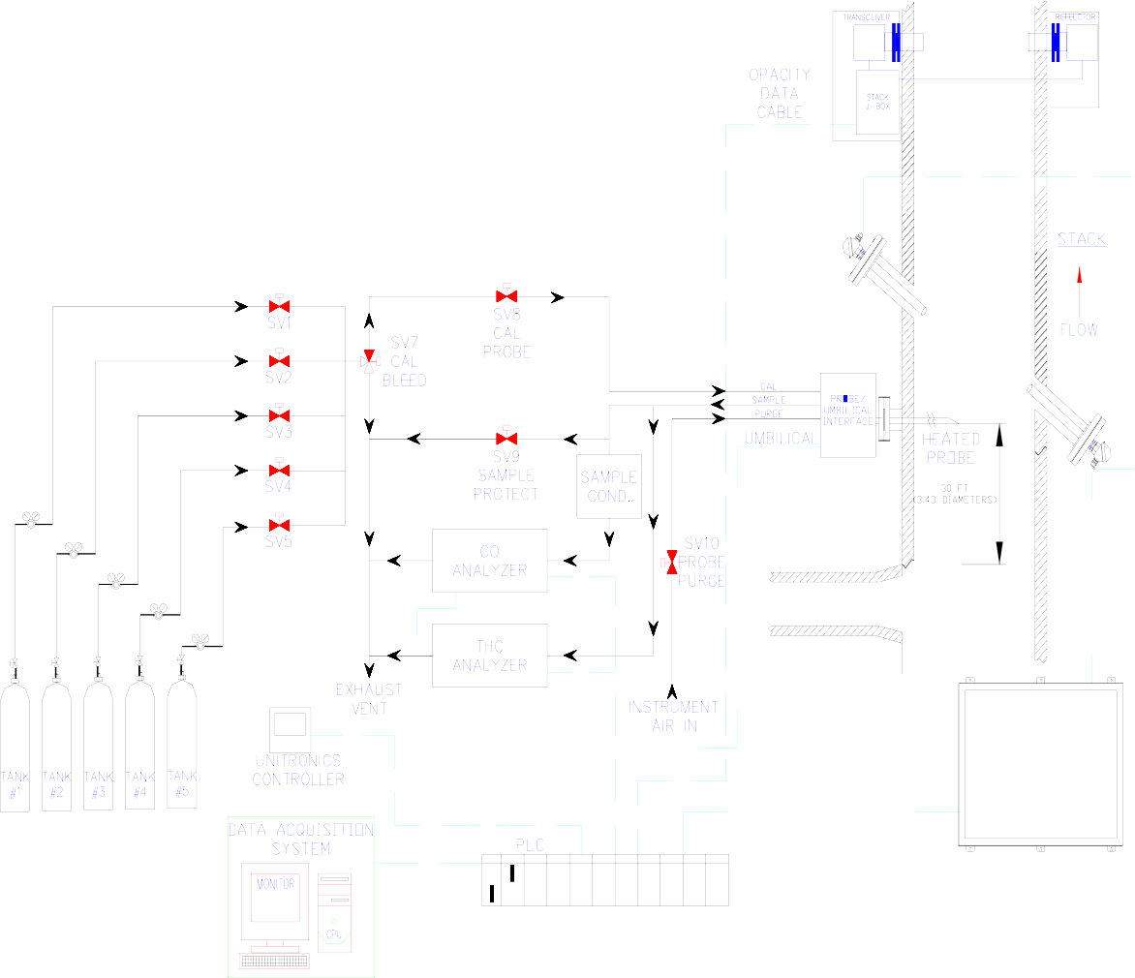
The CEMS is an integrated system manufactured by Monitoring Solutions, Inc. whose headquarters are based in Indianapolis, IN. The following figures present a simplified illustration of t h e CEMS gas flow (reference system drawings for specific component detail).

Figure 1. Dryer RO General CEMS Overview

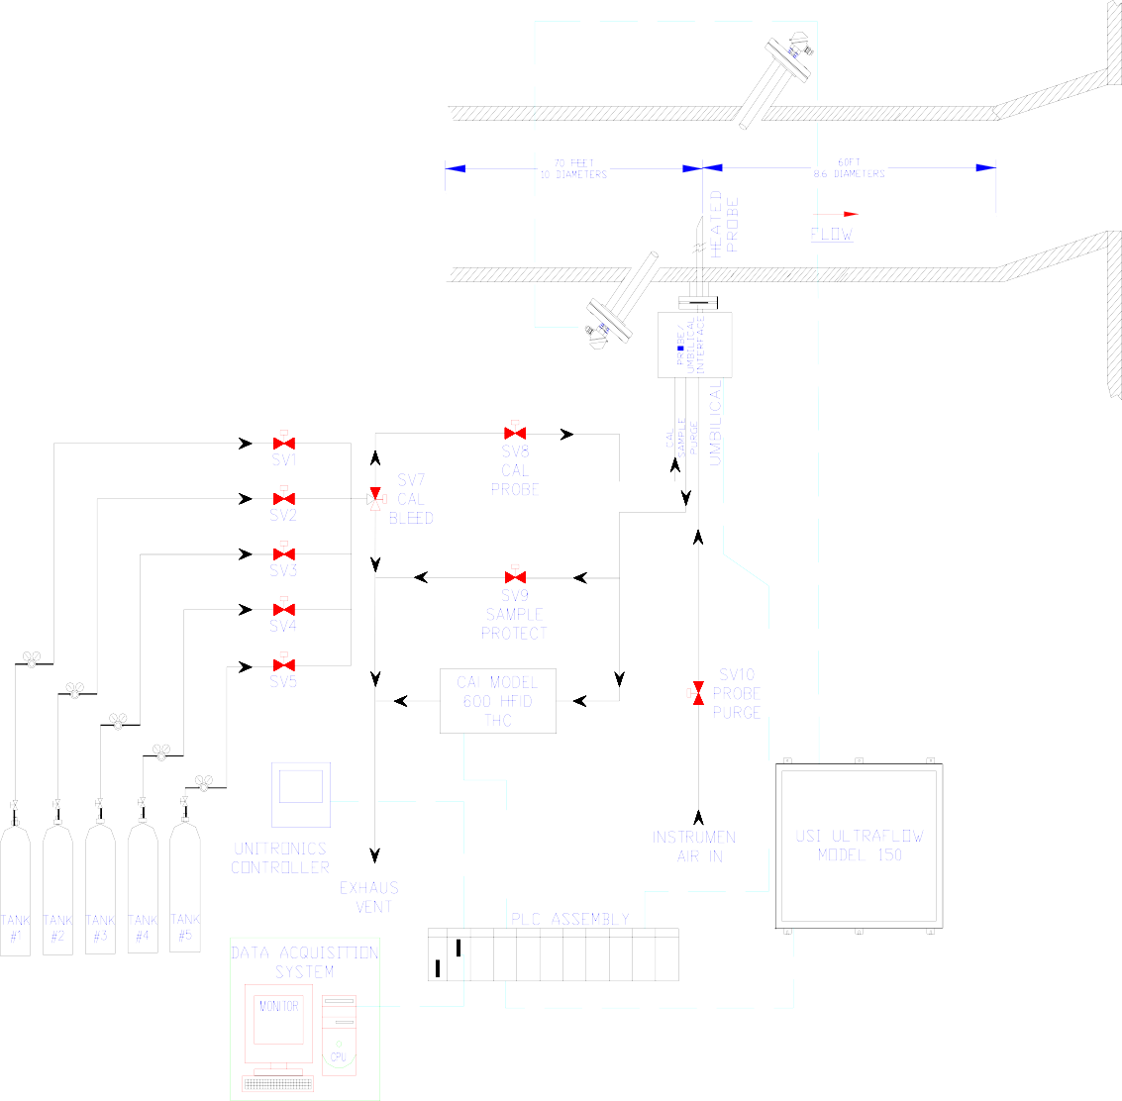
Figure 2. Bio-Filter CEMS General Overview

The RO stack has an internal diameter of 105 inches. The distance from the sampling probe to the nearest downstream disturbance is 40 feet. The distance to the nearest upstream disturbance is 30 feet.

The Press Bio-Filter duct has internal diameter of 84 inches. The distance from the sampling probe to the nearest downstream disturbance is 54 feet. The distance to the nearest upstream disturbance is 85 feet.

CEMS (Continuous Emission Monitoring System) - performs the extractive sampling and measuring of the flue gas. The Sample probe is inserted into the gas stream and extracts a continuous sample of flue gas. The sample pump creates a pressure differential (vacuum) used to extract gas from the stack. The extracted sample is transported via the umbilical system through a gas sample conditioner and gas control panel to specific gas analyzers.

The flue gas is protected by maintaining, or increasing the flue gas temperature as it is being transported (depending on the stack gas temperature). It is also necessary to prohibit the flue gas sample from coming into contact with any material that could alter the concentration of the sample until conditioning is complete. A heat trace installed in the umbilical, regulated by a rack mounted temperature controller, keeps the sample gas at a desired temperature above 220°F.

As the extracted gas enters the Sample Gas Conditioner it is cooled by a thermoelectric cooler (to remove moisture) with a temperature set point of +4°C, run through a particulate filter to remove any other sample contaminates and delivered to the gas control panel. A rotometer controls and monitors the sample flow rate to the CO analyzer. A gauge is provided to monitor sample pressure. The extracted gas for the THC analyzer bypasses the Sample Gas Conditioner and is delivered directly to the analyzer through a heated particulate filter. The gas control panel also controls the flow of excess sample to the sample vent. The sample vent is required to be connected to the outside of the system enclosure by the client.

CEMCON (Continuous Emission Monitoring CONtroller System) - automatically controls CEMS operations such as system purge (blow back) and calibration. The CEMCON system consists of a Unitronics V-130 controller with power supply and a multifunction keypad for operator interface.

A complete set of operation and maintenance manuals for all components of the system is maintained by the Instrumentation Department. These manuals provide complete descriptions of the system including theory, installation, operation, and maintenance.

AIR FLOW (the following description is copyrighted material from United Sciences, Inc., now owned by Teledyne Monitor Labs)

A Teledyne Ultraflow Model 150 airflow monitor was installed on the RO Stack (Serial Number 1501354) in May 2014 and the Press Biofilter outlet duct (Serial Number 1501355) in June 2014.

The Ultraflow Model 150 is a non-contacting gas flow and temperature monitor. Instead of using an S- Type pitot as described in Method 2, Method 1 was used to determine the location of the flow rate monitor. The system measures the transit times of ultrasonic tone bursts through the gas stream to determine velocity, flow volume, and gas temperature. Two transducers are placed across from each other on opposite sides of the stack/outlet duct. Each transducer acts alternately as a transmitter/receiver with the paths of the ultrasonic waves passing through the centroid of the duct. When a tone burst is sent through the gas stream from the upstream transducer to the downstream transducer, the movement of the gas stream reduces the time required to traverse the distance. When the tone burst is traveling against the gas stream from the upstream to the downstream transducer, the traverse time in increased. When there is no gas flow, the time required for the ultrasonic tone bursts to traverse the gas stream in either direction is the same.

As the upstream transducer transmits, the tone bursts travel to the downstream transducer. This time is measured by the Stack Electronics to an accuracy of ± 3 microseconds. When the downstream transducer transmits, the time for the tone burst to travel to the upstream transducer is also measured with the same accuracy.

The flow velocity is directly related to the difference in the time required for the tone bursts to go with and against the gas stream. Based on the cross-sectional area of the stack or duct, the flow velocity is converted to volumetric flow. This flow measurement is inherently independent of the temperature, density, viscosity, and particulate concentration. The flow volume measurement is an area-corrected parameter determined from the average flow velocity along the path between the two transducers.

The basic equations:

1.) V1 = Cs + Fv(cosØ)

Velocity of sound from upstream to downstream transducer 2.) V2 = Cs – Fv(cosØ)
Velocity of sound from downstream to upstream transducer

Where:

Cs = The speed of sound Fv = Flue gas velocity
Ø = Transducer angle to flow

V = velocity of respective tone bursts

Ft = Traverse velocity vector = Fv(cosØ)

3.) Subtract equations 1 & 2: V1 – V2 = 2cosØ(Fv) and solving for Fv: 4.) Fv = V1 – V2
2cosØ

substituting V1 = L and V2 = L

t1 t2

5.) Fv = L . t2- t1

2cosØ t2t1

Fv is the line average velocity.

And: t = Transit times of sound between the transducers L= Distance between the transducers

Temperature Calculations:

Add the basic equations 1.) V1 = Cs + Fv(cosØ)

2.) V2 = Cs – Fv(cosØ)

and

6.) V1 + V2 = 2Cs

Solving for Cs and substituting

V1 = L and V2 = L.

t1 t2

7,8) Cs = 1 L + L = L t2 + t1

2 t1 t2 2 t2t1

Calculate temperature using 9.) T = r (Cs) 2

Where r is a constant related to the specific heat ratio and the average molecular weight of the gas.

By knowing the time required to traverse the gas stream the speed of the sonic tone is calculated. The influence on the speed resulting from temperature is well established. Therefore, the temperature measurement is calculated directly from the speed of sound determination.

Volumetric and Mass Flow:

- Fv may be multiplied by the cross-sectional area to determine the actual volumetric flow, or ACFM

- Pressure and temperature can be used to correct the flow to standard conditions, or SCFM

The flow velocity Fv is now seen to be dependent upon only two variables: Transit Times t1, t2 and the duct geometry.

- The Ultraflow 150’s drift specification is ≤ 1.0 % of reading over the useful life of the monitor.

- The Ultraflow 150’s measurement is independent of the gas composition, temperature, and speed of sound.

Sample Probe

Description

The Model 34C Heated Filter Probe’s primary function is to provide a heated environment to maintain sample gas temperatures above dew point and remove particulate material from the gas sample. The primary components of the probe are: the probe housing where extraction takes place, probe extension, probe heater, thermocouple to monitor temperature, an external regulated heater jacket, the sample pump, a two (2) micron filter and a single direct blowback system to clean the filter element.

The Model 34C comes with a blowback air accumulator tank and 2-way solenoid. To operate blowback, connect a 50-90 psig instrument airline to the blowback air accumulator tank. The customer controls blowback via a PLC or other means, such as the Operator Interface Controller. The 2-way blowback solenoid is rated for high temperature and 100 psig maximum pressure. The valve has a 1/8” orifice and the blowback instantaneous flow rate is 14scfh.

Separate 4” ports are provided on the stack/duct walls at appropriate points around the diameter and in line with the system sample probes for external audit and testing.

Calibration

To route calibration gas to the probe, open the user supplied calibration gas control valve, adjust the cylinder pressure not to exceed 35 psig, and adjust the calibration gas flow rate to 125% to 150% of the total gas sample flow rate (reference the system flow drawing for specific flow requirements).

Maintenance

Typical maintenance on the probe is to clean or replace the filter on a quarterly basis, more often, if necessary. Inspection of all tubing and wiring connections should also be performed. The ceramic filter, O-rings, and blowback solenoid are critical components and need to be part of the spare parts inventory.

Umbilical System

The umbilical is a bundle of pneumatic tubes and electrical wires used to interconnect the probe, the gas analyzers and gas transport system. The umbilical is heated to keep it flexible and free of condensation. The umbilical system contains the following lines:

- One 3/8-in tube for transporting calibration gas to the probe.

- One 3/8-in tube for transporting sample to the analyzers via the gas control panel and the analyzers.

- One 3/8-in tube for transporting instrument / purge air to the probe.

Additional components of the umbilical system include the control wiring for the stack J-box and AC voltage for the probe and umbilical heaters. Two Type "K" thermocouple wires are provided for measuring the temperature of the umbilical and the probe heater. The tube/wire bundle is wrapped in an aluminized Mylar thermal barrier and is surrounded with thermal insulation. The total umbilical system is enclosed in a flexible fire-retardant jacket for protection. The power end is typically marked with yellow tape and the stack end marked with white tape.

Weyerhae

Maintenance Schedule
Figure 1. Full Extractive Umbilical

Preventive maintenance of the umbilical includes a visual inspection of the exterior for any damage or cuts to the outer jacket and any obvious kinking or low spots. Supports should also be considered during the inspection.

Heater Controllers

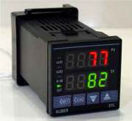

Setup

Figure 2. Auber Temperature Controller

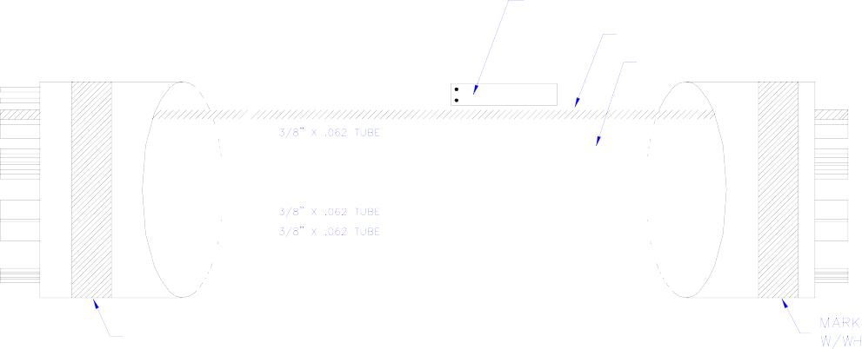

user OSB Grayling – Quality Assurance and Quality Control Plan
Temperatures of the umbilical, probe, THC heated filter, are set by controls located in the system rack. The umbilical temperature should be set to a point between 275°F and 350°F. On a system that is analyzing low concentrations of CO gas emissions, the umbilical temperature set point should be set towards the lower end of the range. The umbilical temperature for both CEMS is set to 325°F.

The full extractive probe temperature should be set to a point between 300°F and 350°F.

For a system utilizing a THC heated filter, the normal probe temperature set point is 350°F. The temperature set point should not be set below 350°F.

Maintenance Schedule

There is no preventative maintenance required for the heater controller assembly. The heater controller systems utilize a solid-state relay. Both heater controller and relay need to be part of the spare parts inventory.

California Analytical Instruments Model 600-HFID THC Analyzer

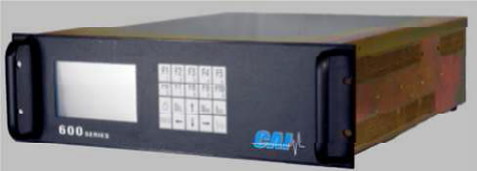

Features
Figure 3. Front Face, CAI Model 600-HFID THC Analyzer

Operating Principle/ Theory of Operation

The California Analytical model 600 HFID uses the flame ionization detection method of determination of total carbon (C) in a sample gas.

The detector is a burner that passes a regulated flow of sample gas, through a flame sustained by a regulated flow of hydrocarbon free air and fuel gas (40% H2 and 60%He). The flame ionizes the hydrocarbon components of the sample gas, producing negatively charged electrons and positively charged ions. A 300-volt polarized electrode collects the ions, causing a very low current to flow. A precision amplifier measures this low current. This current flow is directly proportional to the carbon content of the sample.

The output from the VOC monitor is as ppm propane. This data is used as input to the air quality compliance computer which currently reduces and stores data from the monitors located on the dryers, as well as various production data. The computer is programmed to convert the output from the flow rate monitor (SCFM) and the VOC monitor (ppm VOC as propane) to pounds per hour VOC as carbon using the formula outlined below:

ppm(carbon) =ppm(propane)*3

lb/hr VOC = (ppm VOC as carbon)*(SCFM)*(mol. wt (12 lb/lb-mol))*(l/385.lcf/lb-mol)*(l/le+06)*(60 min/hr)

Description

The CAI Model 600 HFID Heated Total Hydrocarbon Analyzer utilizes a highly sensitive flame ionization detector (FID) for measuring gas Total Hydrocarbon (THC) concentrations in industrial emission applications.

The heated sample gas is maintained above its dew point by a self-contained internally adjustable temperature oven. The oven temperature is adjusted at the factory to be controlled at 190 ºC. The sample gas is maintained at this elevated temperature until it exits the FID’s bypass outlet, thus preventing any loss of hydrocarbon concentration in the sample due to condensation.

General

The Model 600 HFID analyzer has a backlit 3 by 5-inch liquid crystal display and a 20-key data/operation input keypad. The microprocessor-controlled system has 16 digital inputs, 16 digital outputs, 16 analog inputs and 4 analog outputs.

The analyzer has four basic ranges that are scaled at the factory per the customer’s order. These ranges can be re-scaled in the field at any time by the user through the analyzer’s keypad. The analyzer’s analog output signal (0-10VDC, 4-20mA, or 0-20mA) is scaled according to the selected range. The operating range of the analyzer can be selected through the keypad, by a contact closure, via the RS232 or TCP/IP interface or automatically when the analyzer is placed into the ‘auto- range’ mode of operation.


The analyzer can be manually operated from the keypad or remotely via discrete logic, RS-232C or TCP/IP communications. After turning on the analyzer, it needs at least 30 seconds for initialization. During this time, the screen is illuminated. This analyzer has an internal heated sample pump.

IMPORTANT TIP: When the analyzer is powered up, it defaults to access level 1 (User). To operate ALL parameters, check the access level.

This CAI Model 600 HFID is setup at the factory to use 40%/60% Hydrogen/Helium Fuel. Please make sure to use the CORRECT fuel (as specified on the fuel label affixed on the back panel of the analyzer.) Use of incorrect fuel WILL damage the instrument and COULD cause an explosion.

Maintenance Schedule

The normal preventative maintenance required for the analyzer involves changing the Teflon filter at the sample inlet. This part needs to be part of the spare parts inventory.

THC Heated Filter Assembly

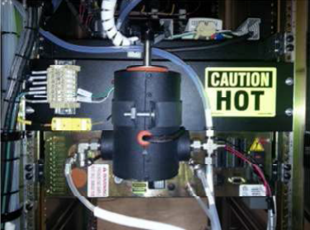

Description
Figure 4. THC Heated Filter Assembly (Internal)

It is critical to maintain the temperature of the gas sample to prevent any loss of hydrocarbon concentration in the sample due to condensation. To do this, the stack gas for the THC sample is routed through a heated filter assembly. This assembly is mounted within an insulated metal enclosure along with a small heater. The temperature is maintained between 350°F and 400°F by utilizing a Type K thermocouple and a temperature controller similar to those utilized by the umbilical and probe heaters.

Maintenance Schedule


The preventative maintenance required for the assembly is noted in the maintenance schedule.

It is important to NOT handle the filter with bare hands. The oils may transfer to the filter and will cause erroneous readings.

California Analytical Instruments Model Series 600 CO Analyzer

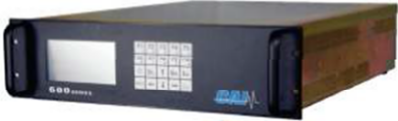

Description
Figure 5. Front Face, CAI Model 600 NDIR Analyzer

The Model 600 series of NDIR analyzers incorporate a single-beam photometric system and a detector with a micro flow sensor assuring high reliability, sensitivity, accuracy, and stability.

The micro flow detector is a sealed unit filled with the same gas as the component of interest (in this case CO). The length of the sample cell determines the range for each component.

Infrared Gas Analyzer Theory of Operation

The infrared gas analyzer measures gas concentration based on the principle that each type of gas component shows a unique absorption line spectrum in the infrared region. The instrument consists of an infrared light source, a chopper, a measuring cell, and a detector filled with a gas mixture containing the gas component to be measured (in this case Carbon Monoxide). The infrared light source emits infrared light in all directions. The light emitted forward is transmitted and reflected into the detectors. The infrared light emitted backward is reflected by a reflecting surface and is added to the infrared light emitted forward. Arranged between the infrared light source and measuring cell is a chopper blade which rotates to modulate the infrared light beam at regular frequency. The modulated infrared light beam thus formed passes through the measuring cell filled with a sample gas where the light energy is partially absorbed or attenuated before it reaches the front chamber of the detector. Both the front and rear chambers of the detector are filled with the gas component to be measured. The infrared light energy is partially absorbed in the front chamber and residual light is absorbed in the rear chamber, thereby increasing pressure in both chambers. Since the detector is designed to produce a pressure difference between the front and rear chambers, a slight gas flow is produced through a path connecting these chambers with each other. This slight flow is converted into an AC electrical signal by a micro flow sensor arranged in the path connecting the chambers with each other. The AC signal is amplified and rectified to a DC voltage supplied to the output terminals and indicator. Amplitude is reduced as the concentration of measured gas component increases.

The output from the CO monitors is used as input to the existing compliance computer which also logs various production data. The computer is programmed to convert the output from the flow rate monitor (SCFM) and the CO monitor (ppm CO) to pounds per hour CO using the formula outlined below:

lb/hr CO = (ppm CO)*(SCFM)*(mol. wt (28 lb/lb-mol))*(l/385.1cf/lb-mol)*(l/le+06)*(60 min/hr)

Maintenance Schedule

The normal preventative maintenance required for the analyzer is to replace the Teflon filter at the sample inlet. Teflon filters need to be part of the spare parts inventory.

Gas Control Panel

Calibration and Purge solenoids

The gas control panel is used to route the calibration gases (both zero air and span gas) to the probe and to regulate the sample flow rate to each analyzer. The sample flow rate is regulated by a flowmeter for each analyzer and should be set to approximately one and one-half l pm for each analyzer. The zero air and the span gas flow are set and monitored by the CALIBRATION GAS flowmeter to approximately one l pm above the sum of the analyzer flows when cal to the probe is active.

The switching of the flows of zero, span, and purge gases is performed by solenoids mounted within the solenoid assembly. The high pressure/volume purge is controlled by a purge solenoid located in the stack probe box. High density Teflon tubing is used to interconnect the gas control panel and the solenoids.

Operator Interface Controller

The Operator Interface Controller controls the activation of the calibration and purge solenoids. Two contacts are provided to the client for remote activation of the Daily Calibration Check sequence and the Quarterly CGA sequence. These sequences, as well as activation of individual solenoids, can be performed manually by an operator at the controller.

The frequency and duration of the probe purges is set within the controller. A “First Purge of the Day” purge time is set and subsequent purges occur based on the frequency (in minutes) set in the controller.

Maintenance Schedule

There is typically no maintenance required for the Gas Control Panel, however, the solenoids should be considered when determining spare parts requirements

Operator Interface Controller

The Operator Interface Controller (OIC) controls the daily calibration check sequence, CGA (Cylinder Gas Audit) sequence, probe purges and individual calibration gas solenoid activation. Activating a calibration gas solenoid will route the corresponding calibration gas to the probe allowing the entire system to be checked. Response time can be affected by several variables including umbilical length, gas flow rate, pump pressure, and inline filters.

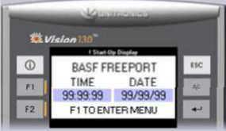

Figure 6. Operator Interface Controller Main Screen

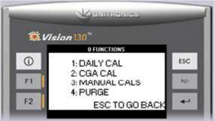

Figure 7. Function Selection Screen

Daily Calibration Check Sequence

The daily calibration check sequence can be initiated at the controller by an operator or by remote contact closures to the controller (Reference System drawings for specific termination points). The sequence for a daily calibration check is Solenoid 1 > Solenoid 2 > Purge.

The duration to which each solenoid will be energized can be set by selecting each solenoid and setting the duration in minutes and seconds. The duration should be set to a time that will allow the system to respond and for the client recording device to collect an appropriate amount of data.

If a solenoid is not being utilized for the daily calibration check sequence, the duration can be set to 1 second. (See Section G.6 for purge duration.)

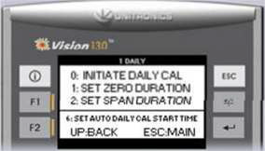

Figure 8. Daily Calibration Check Selection Screen

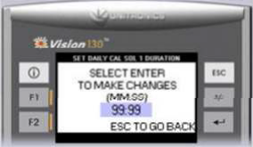

Figure 9. Daily Solenoid Duration Selection Screen

The time for each automatic daily calibration check is set to ensure that the calibration check is performed daily at the same time.

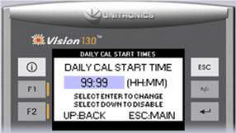

Figure 10. Daily Calibration Start Time Selection Screen

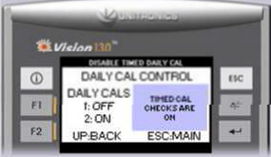

CGA Sequence
Figure 11. Daily Calibration Disable Screen

The cylinder gas audit sequence can be initiated at the controller by an operator or by remote contact closures to the controller (Reference System drawings for specific termination points). The sequence for a cylinder gas audit is Solenoid 1 > Solenoid 2 > Solenoid 3 > Solenoid 4, entire sequence will repeat twice for a total of three (3) runs.

Status of each solenoid, as well as the run number and remaining time for each solenoid will be shown on the CGA Solenoid Status screen during a CGA audit.

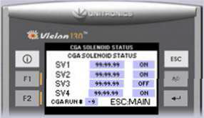

Figure 12. CGA Solenoid Status Screen

The duration to which each solenoid will be energized can be set by selecting each solenoid and setting the duration in minutes and seconds. If a solenoid is not being utilized for the cylinder gas audit sequence, the duration can be set to 1 second.

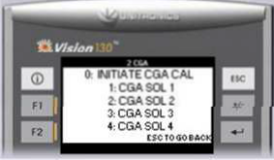
Figure 13. Cylinder Gas Audit Selection Screen

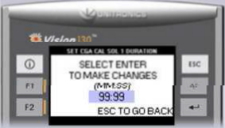

Manual Calibration
Figure 14. CGA Solenoid Duration Selection Screen

Individual solenoids can be initiated manually at the controller.

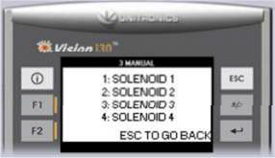

Figure 15. Individual Solenoid Selection Screen

Once a solenoid is activated manually, it will remain on until it is manually shut off. Status of the solenoid will be indicated on the corresponding solenoid calibration screen. Caution should be used on the manual calibration screens because if a solenoid is not turned off after maintenance, it will cause incorrect readings and will expend the calibration gas.

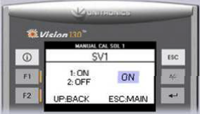

Probe Purge

Figure 16. Individual Solenoid Manual Selection Screen

The system can be set to perform a probe purge at a specific time of day. Any subsequent purges during the day can be set based on the purge frequency. However, the FIRST PURGE OF THE DAY will always be the same and will reset the clock for the purge frequency.

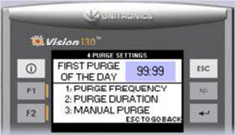

Figure 17. Probe Purge Selection Screen

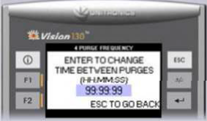

Figure 18. Probe Purge Frequency Selection Screen

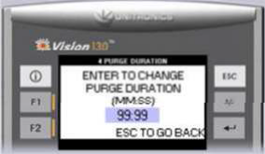

Figure 19. Probe Purge Duration Selection Screen

The purge can also be initiated manually when needed. Once initiated, the remaining purge time will be indicated on the Manual Purge screen. If a user wishes to shut off the purge prior to the set duration, the +/- key will shut off the purge and reset the controller.

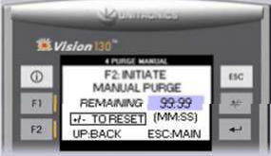

Air Filtering System
Figure 20. Probe Purge Manual Initialization Screen

Instrument Air for a full extractive CEMS is required for purging of the probe. Instrument air is to be supplied by the client at 80psi minimum and the flow requirements vary with the filtering system (reference SYSTEM DRAWINGS for specific air requirements). Air service for the system is supplied by terminating the feed line to the instrument air inlet. The air supply must be oil and particulate free with a dew point of 40°F. In cases where oil is present, the customer is to supply an oil filter prior to the air regulator.

The probe and analyzers require particulate free, dry, air for proper operation. The air filtering system supplied is equipped with particulate and moisture removal at the instrument air inlet. Since the analyzers are operating in the ambient air concentration ranges, any contamination would cause incorrect values to be determined for the stack gas concentrations.

The first filter is a coalescing filter and a moisture trap with an automatic drain. The next two units are canisters with a reagent to scrub gas of concern followed by a fine, particulate filter with a moisture trap. The second filter traps any remaining particulate from the scrubbers, or indicator unit.

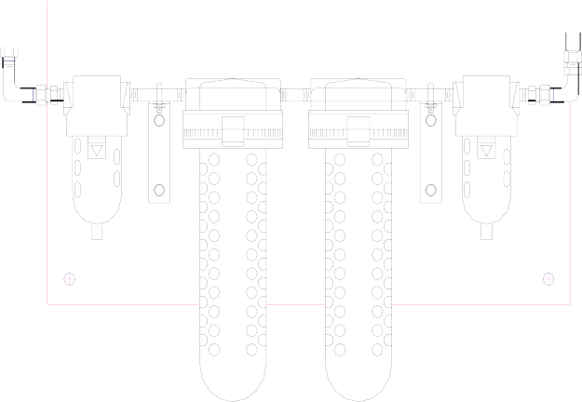
Figure 21. Air Clean Up Assembly Scrubber

An assortment of scrubbers is used to scrub the service air of the gases of concern. Filter elements are replaced quarterly or more often if required.

Quality Assurance Activities

Overview

The purpose of these procedures is to ensure that the CEMS installed at the Weyerhaeuser OSB Grayling - Michigan facility operates in such a manner as to provide accurate and reliable data.

Table 1. Quality Assurance Checklist

Activity: Quality Assurance | Quarterly | Annually
Calibration Gas Audit | X*
RATA |  | X
*3 out of 4 quarters

CEMS Analyzer Summary

Table 2. CEMS Analyzer Summary

Pollutant or  Diluent | Full Scale  Range | Analyzer Mfg. | Model | Serial Number
Dryer RO THC | 0-100 ppm  0-1000 ppm | CAI | 600 | B05009  B05010
Dryer RO CO | 0-500 ppm  0-1000 ppm | CAI | 600 | B06014-M  B06015-M
Press THC | 0-100 | CAI | 600 | B05011

Daily Calibration DriftCheck

Calibration Gases

Calibration gases shall be NIST/EPA approved Standard Reference Materials, Certified Reference materials per 40 CFR 60, Appendix F, Section 5.1.2 (3). A separate calibration gas cylinder must be used for each concentration.

Multicomponent mixtures are acceptable provided that none of the components interferes with the analysis of other components and provided that individual components must not react with each other or with the balance gas.

Calibration Error Test for Pollutant Monitors – Part 60

Perform a two-point calibration error test on each pollutant gas monitor at least once per unit operating day (24 hours). A separate calibration gas cylinder must be used for each audit point. The following concentrations must be used:

Table 3. Daily Calibration gas allowable ranges

Audit Level | 40 CFR 60
Low-level | 0-20% of span

High-level 50-100% of span

Dynamic calibration checks challenging the entire sampling and analysis of the CEMS automatically occur once every 24 hours and are controlled by the PLC. The PLC controls solenoids that open and close to allow low and mid-level calibration gases to be alternately introduced to the pollutant analyzers. Each gas passes through all components used during normal sampling, including the sample probe. Gas is injected until a stable reading is obtained. All analyzer responses during calibration are recorded by THE DATA ACQUISITION SYSTEM. Calibration gas can be manually initiated at any time.

The results of the CD check are calculated as the measurement device reading minus the value of the calibration gas used.

If a post-maintenance zero or calibration drift checks show drift in excess of twice the applicable performance specifications, recalibration must be conducted in accordance with the quarterly calibration error check procedures.

For CEMS, the zero (low-level) and high-level calibration drifts shall not deviate from the reference value of the calibration gas by more than two times the specification for five consecutive days, or four times the specification for one day.

If a monitor fails a calibration error test, corrective action must be performed and documented, and a successful daily calibration error test performed before data can be considered valid. The CEMS calibration must, as minimum, be adjusted whenever the daily zero (or low-level) CD or the daily high-level CD exceeds two times the limits of the applicable PS. The Monitoring Solutions CEMS Operations and Maintenance Manual provides detailed calibration procedures.

Out-of-Control Period for Pollutant and Diluent Analyzers – Part 60

An out-of-control period occurs for a pollutant or diluent analyzers when the daily low-level or daily mid-level CD exceeds two times the limit for five consecutive days, or four times the limit for one day.

Table 4. Out of Control Limits for Pollutant and Diluent Analyzers

Analyzer | Daily Calibration Drift | Out of Control
Analyzer | Daily Calibration Drift | Five (5) consecutive  daily calibrations | Any daily  calibration
THC | ≤ 2.5 % of Span | ≥ 5.0 % of Span | ≥ 10.0% of Span
CO | ≤ 2.5 % of Span | ≥ 5.0 % of Span | ≥ 10.0% of Span

Monitor adjustments, calibration, or repairs must be performed whenever CD limits are exceeded. The CD check must be repeated after any adjustment or repair. Whenever the CD is exceeded, a warning is displayed on the computer screen and a message is logged to a printable alarm file.

The beginning of the out-of-control period is the time corresponding to the completion of the fifth, consecutive daily CD check with a failed CD or the time corresponding to the completion of the daily CD check preceding the daily CD check that results in a failed CD. The end of the out-of-control period is the time corresponding to the completion of appropriate adjustment and subsequent successful CD check.

Any time the CEMS is declared "out of control" or "out of service", it cannot be used to show compliance with permit limits or data capture requirements and shall be considered downtime for reporting purposes. Therefore, corrective action must be performed as soon as possible after determining that the CEMS is not operating to within required specifications.

Quarterly Audit: CEMS – Pt 60

Conduct the test for calibration error on each range of each measurement device, except for fuel flow meters, in accordance with the procedures in 40CFR60 App. B Performance Specifications.

An audit shall be performed on each pollutant analyzer at least once every calendar quarter in which the source operates for 168 hours or more, except that if four consecutive calendar quarters elapse after the last audit, the test must be performed within 168 source operating hours (If source did not operate at all, the provisions of the Extended outage/Shutdown will apply). Successive quarterly audits shall occur no closer than 2 months.

Calibration Gases – Pt 60

Calibration gases shall comply with per 40 CFR 60, Appendix F, Section 5.1.2 (3). Use audit gases that have been certified by comparison to National Bureau of Standards (NBS) gaseous Standard Reference Materials (SRM’s) or NBS/EPA approved gas manufacturer’s Certified Reference Materials (CRM’s) following EPA Traceability Protocol No. 1. As an alternative to Protocol No. 1 audit gases, CRM’s may be used directly as audit gases. A separate calibration gas cylinder must be used for each audit point. The following concentrations must be used:

Table 5. Calibration gas allowable ranges – Part 60

Audit Level | Pollutant Monitors
Low-level | 20 - 30 % of span
Mid-level | 50 - 60 % of span

Procedure

The known gases are individually injected at the probe to be sampled through the entire sampling train, as the path used in extracting stack gas from the process. Gas is injected until a stable reading is obtained.

The procedure is conducted as follows:

- Connect all quarterly gas cylinders to the system and turn them on.

- Verify/Set the corresponding calibration gas cylinder values in the calibration configuration menu in the DAS.

- Then initiate the sequence by selecting the CGA option on the DAS screen or the Unitronics controller.

- Each gas is routed through the system until a stable response is achieved.

- Values are recorded as the system is allowed to operate in a normal sampling and analysis manner without adjustment.

- The sequence is repeated through three audit runs.

For each audit cylinder (or audit point), the percent accuracy is determined by using the following equation:

Where:

A = Accuracy of CEMS (%)

A= (Cm-Ca)

Ca

x100

Cm = Average CEMS response during audit in units of applicable standard or concentration
Ca = Average audit (cylinder gas certified value) in units of applicable standard or concentration Accuracy (A) value of +15% or less is considered acceptable for criteria pollutants gas. If excessive
inaccuracies occur for two consecutive quarters, Weyerhaeuser OSB Grayling must revise the QC
procedures or modify or replace the CEMS.

Measurements are calculated and recorded by the PLC. The audits serve as verification of the accuracy of the CEMS data. Various reports can be generated to support audits and are kept on file by Weyerhaeuser OSB Grayling. The manufacturer's certification statement (if applicable) for the calibration gases are also included.

Periodic Audit

Relative Accuracy Test Audit

At least once in every four calendar quarters, conduct a Relative Accuracy Test Audit (RATA), as described in 40 CFR 60, App. B, PS 2, to assess the accuracy of the CEMS relative to the appropriate EPA reference methods used in determining stack gas concentrations. Measured inaccuracy exceeding 20% of the mean value of the reference method results or 10% of the applicable standard, whichever is greater, requires corrective action to be taken. When appropriate, additional audits are conducted to demonstrate the effectiveness of the repair or adjustment.

RATA Preparation

A number of quality assurance activities are undertaken before, during, and after each audit. The following paragraphs detail the quality control techniques, which are rigorously followed during the testing projects.

Each instrument’s response is checked and adjusted in the field prior to the collection of data via multi-point calibration. The instrument’s linearity is checked by first adjusting its zero and span responses to the zero nitrogen and an upscale calibration gas in the range of the expected concentrations. The instrument response is then challenged with other calibration gases of known concentrations and accepted as being linear if the response of the other calibration gases agreed within
±2 percent of range of the predicted value.

After each test run, the analyzers are checked for zero and span drift. This allows each test run to be bracketed by calibrations and documents the precision of the data just collected. Data is considered acceptable if the instrument drift is no more than 3 percent of the full-scale response. Quality assurance worksheets are prepared to document the multipoint calibration checks and zero and span checked performed during the tests.

The sampling systems are leak checked by demonstrating that a vacuum greater than 10 in Hg could be held for at least 1 minute with a decline of less than 1 in Hg. A leak test is conducted after the sample system is set up and before the system is dismantled. These checks are performed to ensure that ambient air has not diluted the sample. Any leakage detected prior to the tests would be repaired and another leak check conducted before testing commenced.

The absence of leaks in the sampling system is also verified by a sampling system bias check. The sampling system’s integrity is tested by comparing the responses of the analyzers to the calibration gases introduced via two paths. The first path is directly into the analyzer and the second path via a sample system at the sample probe. Any difference in the instrument responses by these two methods is attributed to sampling system bias or leakage. The criteria for acceptance are agreement within 5% of the span of the analyzer.

RATA Activities - CEMS

- Verify that all plant operations will be normal (e.g., no scheduled maintenance) and that no other condition exists which could prevent testing emissions under representative operating conditions.

- Verify the availability of all personnel required to perform testing.

- Verify that test location conditions are adequate for testing, and that necessary support services are available.

- Verify that all scheduled maintenance on the CEMS has been performed.

- Perform the following procedures immediately prior to, during, and following RATA testing:

- Perform and document a pre-test calibration of the CEMS.

- Notify appropriate levels of the organization of testing.

- Verify CEMS operating conditions are normal by conducting walk-through audits.

- Verify load remains stable and at least 50% of maximum prior to, and during, testing.

- Perform and document a post-test calibration of the CEMS if necessary.

AIR FLOW MONITOR QUALITY CONTROL CHECKS

The zero-calibration check is accomplished by transmitting a tone burst at twice its normal rate from the upstream transducer while the other transducer only receives. The electronics process the received signals in an alternate manner. Since all received signals go through the gas stream in the same direction, the time required to traverse the gas stream should be the same. With no difference in the traverse times, the flow should indicate zero.

The calibration span check is conducted by transmitting a tone burst at twice the normal rate from the downstream transducer. In the zero-calibration mode, the output would be zero. However, in the span mode, every other received tone burst is delayed by a fixed amount. This means that the processor believes there is a difference in the time required for the tone bursts to traverse the gas stream. This results in a predictable upscale flow indication.

Calibrations on the air flow monitor are conducted hourly. The zero-calibration check is conducted on even hours and the span calibration check is conducted on odd hours. Calibration zero and span check data is stored in the database collection system.

Quality Control Activities

Quality control activities are performed to ensure that the CEMS operation and maintenance are adequate and appropriate. Application of these activities ranges from installation to data handling and reporting procedures. Quality control activities rely upon a qualified and well-trained staff.

Installation of the CEMS has been carried out in strict accordance with specifications submitted by Weyerhaeuser OSB Grayling. A complete set of Operation and Maintenance manuals for all components of the CEMS are provided with the CEMS. These manuals provide complete descriptions of the system including theory, installation, operation and maintenance including procedures used for initial start-up, debugging, and inspection.

Quality Assurance/Quality Control Plan

Each source owner or operator must develop and implement a QC program. As a minimum, each QC program must include written procedures which should describe in detail, complete, step-by-step procedures and operations for each of the following activities:

- Calibration of CEMS.

- CD determination and adjustment of CEMS.

- Preventive maintenance of CEMS (including spare parts inventory).

- Data recording, calculations, and reporting.

- Accuracy audit procedures including sampling and analysis methods.

- Program of corrective action for malfunctioning CEMS.

Standard Operating Procedures

The VOC and flow rate monitors go through the startup and operation procedures as described in the owner’s manual. The monitors are only shut down for maintenance. If production at the facility has slowed down or stopped the monitors continue to operate.

CEM System Inspections and Preventive Maintenance

Daily inspection and preventive maintenance actions are recorded on a check sheet, dated, signed and maintained with the instrument records.

Periodic and Refresher Training

Each affected employee receives appropriate training as SOP's, operating parameters, or as personnel changes are made.

Record Keeping

The Environmental Manager or EHS Coordinator will be responsible for training as the need arises.

QC
Activities

An activity matrix summarizing various routine activities is presented in the following table. The Plant Maintenance Manager is ultimately responsible for scheduling routine maintenance and ensuring that all routine preventive maintenance is completed on schedule.

Table 6. Quality Control Checklist

Activity: Quality Control | Daily | Quarterly | As  Required
DAS Alarms Status | X
Analyzer Alarms Status | X
Zero Value Cal Check Passed/Record | X
Span Value Cal Check Passed/Record | X
Calibration gas cylinder(s) >250psi | X
Walk-through Audit |  | X
Clean/Replace Filters - Analyzers |  | X
Clean/Inspect Sample Conditioner |  | X
Replace/Clean Filters - Probe |  | X
Replace/Clean Filters – THC Heated Filter |  | X
Change Air System Filters/Scrubbers |  | X | X
Leak Check Gas/Flow Connections |  | X | X
Clean Interior of Enclosure/Rack |  | X | X

Routine Maintenance and Schedule

- Daily Check. Check the analyzer visually after the 24-hour calibration check. Check or confirm the following while monitoring.

  - Flow rate on all rotometers. Make a note of the acceptable range on the meter
  - Check sample system pressure.
  - Check sample line temperature.
  - Check calibration, zero, hydrogen, gas pressure level on instrument panel and on regulator.

- Weekly Check.

  - Check sample line filter.
  - Check sample line and calibration lines for plugging.
  - Check compress gas inventory level.

- Quarterly Maintenance

  - Check that shelter cabinets are clean and the area maintained; monitor enclosure clean and all
systems operational (i.e., heating/cooling).

  - Clean/Replace sample inlet filters on all analyzers. Clean the analyzer screens.
  - Clean/Inspect sample conditioner.
  - Check the filter bowl for excess moisture.
  - Replace the peristaltic tubing.
  - Clean/Replace filter on the sample probe.
  - Replace filter elements and scrubbers on the air clean up system.
  - Clean/Replace THC Heated filter element.
  - Inspect/Leak check all gas connections

- Every Other Week-Maintenance Check and Test.

The preventive maintenance check is recommended at least quarterly and consists of inspecting, testing and adjusting. Blow back all sample lines and then shut off the sample flow, air, hydrogen and power from the cabinet before inspecting or maintaining the unit. If specified results are not obtained, refer to the troubleshooting procedures explained in the instrument manuals.

Inspect the CEM system as follows:

  - Open the cabinet doors.

  - Remove screws and open front panels from the Hydrocarbon analyzer and flow monitor

  - Check for evidence of corrosion, water or other obvious damage to wiring, tubing, optical filters, sample cell, lamps and mounting, and amplifier unit.

  - Check for loose connections on terminal board wiring and plugs.

  - Check security of ground connection between amplifier chassis and TB-3.

  - Check FID and flow indicator tube mounting security.

  - Check sampling system and flow monitor for evidence of leaks.

  - Check FID and flow indicator tubes for cleanliness.

  - Check heated chambers, and for evidence of overheating. Some discoloration of insulation is normal.

  - Check probe filter system, for cleanliness, corrosion, and leaks.

  - Check flow monitor sample chamber for cleanliness.

  - Check flow meter, tubing, vacuum regulator, valves, gauges, for condition and security.

  - Check, repair, or tighten any damaged or faulty part.

  - Inspect the power supply and sample lines as follows:

    - Check wiring and components for evidence of overheating and corrosion

    - Check connections for security

- Replace any damage or faulty part

* If everything is satisfactory, replace the analyzer access panels.

Air Flow Monitor Calibration Procedures

Daily calibration zero and span checks are conducted on the air flow meter. The zero-calibration check is accomplished by transmitting a tone burst at twice its normal rate while the other transducer only receives. The electronics process the received signals in an alternate manner at all times. Since all received signals go through the gas stream in the same direction, the time required to traverse the gas stream should be the same.

The calibration span check is also conducted by transmitting a tone burst at twice the normal rate from the downstream transducer. In the zero-calibration mode, the output would be zero. However, in the span mode, every other received tone burst is delayed by a fixed amount. This means that the processor believes there is a difference in the time required for the tone bursts to traverse the gas stream. This results in a predictable upscale flow indication.

Daily calibration zero and span check data is stored in the compliance computer.

VOC MONITOR

The Press VOC monitor range is 0-100 ppm. The monitor span is 100 ppm. Daily calibrations of the VOC monitor will be performed automatically pursuant to the requirements outlined in the Part 60.13. A calibration gas generator or pure, bottled, protocol nitrogen gas (99%+) will be used as the zero level calibration gas for the daily zero calibration and during quarterly quality assurance calibration gas audits. Calibration drift will be determined at the zero and high-level calibration level. Calibration drift must not exceed two times the limits of the applicable performance specifications. The calibration drift data will be recorded in the compliance computer.

The linearity of the monitor is better than 1% of the full scale (100 ppm). The resolution detection limit is 10 ppb carbon. Response time is 90% full scale in 1.5 seconds. Accuracy is better than 2% of reading at or above 2.0 ppm. Readout as ppm C3H8.

Preventive Maintenance Procedures

The repetitive PM’s and Work Orders are tracked in the SAP system electronic database.

AUDIT PROCEDURES

Cylinder Gas Audit

The cylinder gas audit procedures and calculations which are followed can be found in Performance U.S. EPA Performance Specification 2 (PS 2). The cylinder gas audit tests will be performed in three calendar quarters, followed by the relative accuracy test in the last quarter.

Relative Accuracy Test Audit

The RA test procedures and calculations which will be followed can be found in PS 2 and PS 8, located in Appendix B. An emission rate in pounds per hour (lb./hr.) total VOC is calculated using the parameters measured from the above described Reference Methods. The emission rate calculated by the CERM system in lb./hr. along with the emission rate calculated by the Reference Monitors (RM) will be used to calculate the RA of the CERM system using the formulas in PS 2. The RA test will be performed once a year following three-cylinder gas audits.

The relative accuracy of the CERM system must be no greater than 20 percent of the mean value of the RM's test data in terms of lb./hr., or 10 percent of the applicable standard, whichever is greater.

Data Backup Procedures

All data collection required under the permit is performed by a PLC and personal computer control system located in various parts of the mill. This system utilizes a remote I/O network called Modicon Momentum I/O which interfaces with field sensors and process sensors and the control system. The control software operating on the PLC is called Concept and the Operator Display software is Wonderware. The database collection software is Aspen Tech IP21. The entire system is designed to minimize downtime. The data which is stored on the database collection system is backed up continuously to prevent loss of data.

Training Procedures

Training procedures are in place to train operators and on-shift maintenance members on the VOC and flow rate monitors. Operators and on-shift maintenance members are trained in the actual operation of each monitor and supporting sampling equipment. Manuals of the monitors are available to all operators and maintenance members to assure proper operation of the sampling system.

CEM System Security

The security of the recorded data is accomplished by assigning only a limited number of individuals access the PLC program, HMI display, and the database storage program.

CEMS
Maintenance

All maintenance of the CEMS can be classified into one of these three areas:

- Routine preventive maintenance. This is a regularly scheduled set of activities designed to prevent problems before they develop.

- Non-routine preventive maintenance. This set of activities is designed to prevent problems, which cannot be predicted. These procedures are performed on an as-needed basis. For example, if sample vacuum on the analyzer drops from its normal reading, the pump, gauge or sample capillaries should be replaced or cleaned. Non-routine preventive maintenance is not discussed in this plan since the procedural methods must be developed as the need dictates.

- Corrective Maintenance. Those activities required to correct problems that occur due to equipment malfunction. Corrective maintenance actions are determined and performed by the Monitoring Solutions maintenance technician or other qualified personnel based on the nature of the malfunction.

All preventive maintenance is scheduled and performed in a timely manner by the Instrumentation Team.

Spare Parts Inventory

The Technician or Operator will:

- Maintain a spare parts inventory adequate to meet the normal operating requirements.

- Maintain the spare parts inventory based on vendor recommended lists.

- Modify the current inventory on an "as required" basis.

A list of the parts recommended to adequately maintain the normal operating requirements of the CEMS is located in the CEMS Operations and Maintenance Manual.

Data Recording and Reporting

General Requirements

An effective quality assurance program communicates the results of QA/QC activities to all affected parties. This QA plan makes provisions for the proper recording and communication of QA and QC information and provides the necessary mechanisms for triggering corrective actions based on the contents of QA/QC reports.

Documentation of QA/QC data and information is an integral part of this QA Plan. This section describes reports and other records that provide appropriate documentation of QA/QC activities. Weyerhaeuser OSB GRAYLING utilizes two primary means of documentation:

Data Acquisition System

The data for the CEM system collected in a dedicated PLC located in the Dryer Control Room. This PLC collects the information from the various data sources such as the CEM monitors and from the process. The data comes into the PLC using analog input modules which are accurate to +/- 0.1 % of full scale. The data is being displayed in both the Energy Control Room and the Press Control Room on a dedicated display using a Wonderware application. The data points, as they are being collected, are stored on an IP 21 database storage system. This system deposits its data into a database server where the information can be retrieved for reports and analysis. The system is powered by one or more Uninterruptible Power Supplies for reliability. The computer system annunciates audible and visual alarms in the event of exceedance and fault conditions. The computer will record the date, time, and the maximum reading of the event on an electronic database where the operator can describe the event along with any action taken to correct the upset or malfunction.

The data collection software samples the CEM systems once every second. The samples are averaged into data points in six-minute, one hour, eight-hour, twenty-four hour, and thirty day rolling averages. For the six-minute rolling average, six one second data readings are averaged for a "six second" data point. The sixty data points are averaged for the six-minute rolling average. For the one hour rolling average, 360 one second data readings are averaged for a "six minute" data point. The ten data points are averaged for the one hour rolling average. For the eight-hour rolling average, 360 one second data readings are averaged for a "six minute" data point. The eighty data points are averaged for the eight-hour rolling average. For the twenty-four-hour rolling average, 240 "six second" data readings are averaged for a twenty-four-minute data point. The sixty data points are averaged for the twenty-four-hour rolling average. For the thirty-day rolling average, 90 eight-hour data readings, one every 8 hours, is rolled up into the thirty-day average. The eighty data points are averaged for the eight-hour rolling average. Finally, the total pounds of VOC for the month are calculated for the month and are maintained in a rolling total consisting of 12 data points for the last year.

Manually prepared QA/QC forms, logs and reports.

All data must be available for review for a minimum of five (5) years from the date of each record and be available to the Division upon request at any time. It can be presented as either a computerized database or printed emission logs.

All reporting is to be on an Eastern Standard Time basis.

The data acquisition system is capable of reading all values over the full range of each measurement device and creates a permanent record of all required raw and calculated data for storage, review and reporting. In addition, a continuous readout in units of each applicable emission standard or operating criteria is collected.

Notification, Reporting and Record Keeping requirements

- In the event of any malfunction or breakdown of process or emission control equipment for a period of four hours or more which results in increased emissions, the owner or operator shall submit a written report which describes the cause of the breakdown, the corrective actions taken, and the plans to prevent future occurrences. This report must be submitted by means that would insure the Division’s receipt of the report by no later than seven days after the occurrence. The information submitted shall be adequate to allow the Division to determine if the increased emissions were due to a sudden and unavoidable breakdown. Such a report shall in no way serve to excuse, otherwise justify or in any manner affect any potential liability or enforcement action.

- Weyerhaeuser OSB Grayling shall maintain records of the occurrence and duration of any startup, shutdown, or malfunction in the operation of an affected facility, any malfunction of the air pollution control equipment or any periods during which a continuous monitoring system or monitoring device is inoperative.

- Weyerhaeuser OSB Grayling shall submit a written report postmarked within 30 days after the semiannual period as prescribed by the Division semiannual. The semiannual periods shall cover the periods of January 1 to June 30 and July 1 to December 31. The report shall contain as a minimum, the following:

  - The nature and cause of the deviation, the time and date of occurrences, and any initial and final corrective action taken.

  - A summary of any days for which any of the required operation and maintenance surveillance checks were not made and the reason for such failure to perform the surveillance.

  - Any corrective actions taken to prevent any further deviations.

Maintenance Record

The Maintenance Record is maintained in the SAP maintenance system. The Maintenance Department enters descriptions of preventive and remedial actions performed on the monitoring system components. These entries are kept in the maintenance files. This record also documents the use of spare parts. A periodic review of the CEMS maintenance record provides a guide to possible problem trends with the CEMS and input as to the needs of the spare parts inventory.

Component Addition, Maintenance or Replacement

Maintenance

- Zero and calibration drift checks are conducted automatically on a daily basis. Values can be checked immediately prior to any maintenance as necessary

- Zero and calibration drift checks must be conducted immediately following any maintenance.

- If the post-maintenance zero or calibration drift checks show drift in excess of twice the applicable performance specifications, recalibration must be conducted in accordance with the quarterly calibration error check procedures.

Addition or Replacement

Scheduled addition of or replacement of components or software programs with components or software programs of different makes or models requires submittal of the record of proposed maintenance prior to such change. For unscheduled addition of or replacement of components or software programs with components or software programs of different makes or models, submittal of the record of conducted maintenance must be made as soon as possible after such replacement. Successful completion of performance testing may be required prior to use of data from the monitoring system. Contact the Department for specific instructions.

Addition of or replacement of components or software programs with like makes and models may require successful completion of performance testing prior to use of data from the monitoring system. Contact the Department for specific instructions.

Troubleshooting

Recommended troubleshooting procedures are located in the CEMS Operations and Maintenance Manual.

Glossary of Terms and Acronyms

Accuracy The measure of the closeness of a measurement to its true value. Although the true value of gas is not known, it can be approximated using an appropriate standard of reference. For example, a National Institute of Standard and Technology Standard (formerly NBS) Reference Material (NIST-SRM) is a primary standard used to assess accuracy. Secondary standards are also used as an approximation to the "true value" although errors may be introduced using these secondary standards.

Analyzer Instrument that measures concentration of a specific gas - such as CO2, CO, O2, NOX, or SO2 - in a flue gas sample.

ANSI American National Standards Institute - a standards-making organization. Attenuate To lessen the amount, force, magnitude, or value of (light).
Audit An audit is an independent assessment of the accuracy of data. Independence is achieved by having the audit performed by an operator other than the person conducting the routine measurements and by using audit standards and procedures different from those routinely used in the monitoring.

CAI California Analytical Instruments. Manufacturer of the CO, and THC analyzers in the CEMS

Calibration

Drift (CD) The difference in the CEMS output reading from a reference value after a period of operating during which no unscheduled maintenance, repair, or adjustment took place. For opacity, the reference value is supplied by a reflecting mirror and a neutral density filter or screen which can be automatically or manually inserted into the light beam path of the monitor. For pollutant analyzers, the reference value is supplied by injecting gases of known values into the system. The CD error is calculated as the difference between the correct value and the observed value for the zero and upscale calibration value.

Calibration Error

Test (CE) A calibration error test is a performance audit of a CEMS in which a three-point audit is conducted.
For opacity, three certified neutral density filters (low, mid, and high-range) are placed in the monitor light beam five nonconsecutive times and the monitor responses are recorded from the opacity data recorder. For CEMS analyzers, three known reference gases are used. From the data, a calibration error is calculated.

cc cubic centimeter - A unit measure of volume equal to 1 milliliter (ml).

CEMCON CEM Controller - A sub system that provides control logic for numerous activities, including daily automatic calibration error check and quarterly cylinder gas audit. The CEMCON collects and passes test data to the DAS for processing.

CEMS Continuous Emissions Monitoring System. The total equipment required for the determination of stack gas concentrations, flow, or opacity on a continuous basis.

CFR Code of Federal Regulations. The CEMS is designed to help the user meet their applicable

requirements.

CGA Cylinder Gas Audit.

DAS Data Acquisition System.

Stack gas The gas produced as a result of combustion or some other industrial process. The gas may be made up of multiple components such as particulate matter, liquids, condensed solids, vapors, and gases. The stack gas may also be referred to as: stack gas, flue gas, duct gas or smoke.

EPA Environmental Protection Agency; regulating body that oversees and controls environmental issues.

HMI Human Machine Interface – Operator interface typically mounted at the equipment location to assist in maintenance activities. See also MDU.

In Hg Inches of mercury, a unit measure of pressure (One atmosphere = 14.696 psi = 0 psig = 29.921 in Hg = 406.8 in WC).

LPM (l/min) Liters per minute

Monitor Instrument that measures a flue gas characteristic such as opacity or flow.

Monitor

Malfunction Any interruption in the collection of data as a result of the failure of any component of the CEMS to operate within specifications of the manufacturer or Performance Specification.

SDS Safety Data Sheet - Standardized format sheet containing health, safety, fire, first aid, chemical properties and other necessary information supplied by manufacturer of hazardous materials.

NBS National Bureau of Standards - an agency of the US government chartered to maintain standards of measurement.

NEMA National Electrical Manufacturers Association - a standards-making organization. CEMS enclosures (e.g., junction boxes, instrument racks, switch boxes, etc.) are rated by their manufacturers to meet various NEMA standards.

Performance

Audit A quantitative evaluation of CEMS operation. Usually the accuracy of the CEMS is determined by using known reference standard.

PPM (or ppm) Parts per million, a measure of concentration (1000 ppm = 0.1%). psi Pounds per square inch - a unit of measure of pressure.
psig Pounds per square inch gauge. QA/QC Quality Assurance/Quality Control
RATA Relative Accuracy Test Audit (performed semi-annually or annually, depending on results from the previous RATA).

Routine

Maintenance An orderly program of actions designed to prevent the failure of monitoring parts and systems during their use.

SOP Standard Operating Procedure. Span (Daily) Refer to Upscale Calibration Value.

Upscale Calibration

Value Sometimes referred to as the span or daily span. The calibration check of the CEMS is performed by simulating an upscale condition. For pollutants and diluents, the upscale value is simulated with a calibration gas.

Zero A simulated or actual level where the system value is at zero (0) percent. For CEMS analyzers, zero is simulated using known standards, typically calibration gases, where the value is at zero (0).

Attachments

Press Bio-Filter CEMS daily checklist Dryer CEMS daily checklist

Press CERMS for VOC's Daily Checklist and Dust Collection System Daily Checklist

Inspected By: Certified Visual Emmission Reader? 
Date: Time:

Team:










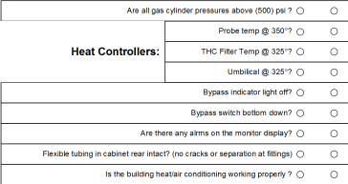


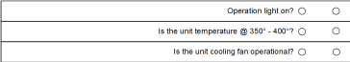
P E N

Are all gas cylinder pressures above (500) psi ?

Probe temp @ 350°?

Heat Controllers: THC Filter Temp @ 325°?

Umbilical @ 325°? Bypass indicator light off? Bypass switch bottom down?
Are there any alrms on the monitor display? Flexible tubing in cabinet rear intact? (no cracks or separation at fittings)
Is the building heat/air conditioning working properly ?


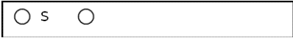
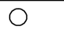
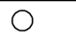
Tripp-Lite Unit
S

Online indicator light - Online?

Yes No

Yes

No

Peak Scientific Laboratory Gas Generator

Operation light on? Is the unit temperature @ 350° - 400°?
Is the unit cooling fan operational?

Comments:

Baghouse/Dust Collection System Checks
Are there any Leaks that cause visual emissions from cyclones, baghouses, ductwork, explosion vents, abort gates, dampers and blowers?

Mat Trim System: Dry Bin Clean-up:
Formline Dust Control System: MDI Dust System:
Comments:(Include any follow-ups or action taken)

If dust leaks are detected and can NOT be repaired when found, notify your teams certified smoke reader or Kathi Moss for a Method 9 reading.
Baghouse sweep arm or air pulsing system operating normally?

Mat Trim System: Dry Bin Clean-up:
Fromline Dust Control System: MDI Dust System:
Comments:(Include any follow-ups or action taken)

Enter the Baghouse pressure drop reading for each baghouse.
Mat Trim System: (dp should be greater than 0.1" and less than 3")
Dry Bin Clean-up: (dp should be greater than 0.1" and less than 4") Formline Dust Control: (dp should be greater than 0.1" and less than 3") MDI Baghouse: (dp should be greater than 0.1" and less than 3")

If RADAR system is OFF, please enter "OFF" instead of "0" in the space for the dp reading.
This document is for reference only. It is not a controlled document.

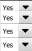
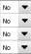
EF015 Document Printed 12/23/2014 ISSUE/REVISION DATE 10/16/14

DRYER CERMS - DAILY CHECKLIST


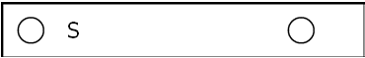
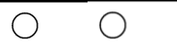
Inspected By: Date: Time:

S

Team:
P E N

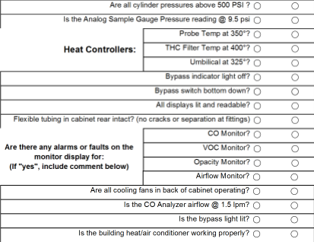
Analyzers Yes No
Are all cylinder pressures above 500 PSI ? Is the Analog Sample Gauge Pressure reading @ 9.5 psi
Probe Temp at 350°?

Heat Controllers: THC Filter Temp at 400°?
Umbilical at 325°? Bypass indicator light off? Bypass switch bottom down? All displays lit and readable?
Flexible tubing in cabinet rear intact? (no cracks or separation at fittings)

CO Monitor?

Are there any alarms or faults on the VOC Monitor?
monitor display for: Opacity Monitor?
(If "yes", include comment below)

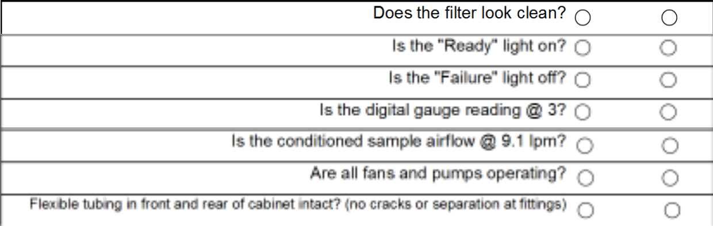
Permapure Sample Conditioner/Cooler
Airflow Monitor? Are all cooling fans in back of cabinet operating?
Is the CO Analyzer airflow @ 1.5 lpm?

Is the bypass light lit? Is the building heat/air conditioner working properly?
Is the "Ready" light on? Is the "Failure" light off?
Is the digital gauge reading @ 3?
Does the filter look clean?

Tripp-lite unit
Is the conditioned sample airflow @ 9.1 lpm?

Are all fans and pumps operating?

Flexible tubing in front and rear of cabinet intact? (no cracks or separation at fittings)
Online indicator light - Online?
Yes No

Yes No

Comments:

This document is for reference only. It is not a controlled document.

EF016 Filename:dCERMS Document Printed 1/7/2015 ISSUE/REVISION DATE 10/16/14

