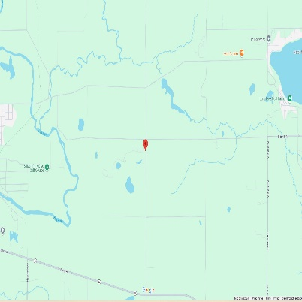
NOTICE of AIR PERMIT PUBLIC COMMENT PERIOD
The Michigan Department of Environment, Great Lakes, and Energy (EGLE), Air Quality Division (AQD) uses public comment periods and hearings to get community input. The public comment period and public hearing (if requested) are to allow the public the opportunity to comment on the proposed conditional approval of the air permits.
There is a public comment period until January 22, 2025, for:
Company: Pitsch Sanitary Landfill, located at 7905 Johnson Road in Belding, Michigan.
What they want to do: Renew their Title V Renewable Operating Permit (ROP) No. ROP0000570 v4.0
- Large emitters of air pollutants, called “major stationary sources” are required to obtain and operate in compliance with an ROP pursuant to Title V of the federal Clean Air Act of 1990 and Section 5506(1) of Part 55, Air Pollution Control, of the Natural Resources and Environmental Protection Act, 1994 PA 451, as amended.
- The ROP is intended to simplify and clarify a facility’s applicable requirements and compliance with them by including all state and federal air quality requirements into one document.
- The proposed ROP will result in no emissions change at the facility.
Facility Responsible Official: Gary Pitsch, Vice President.
Tell us what you think in any of these ways:

Get technical reports about this project:
- Online at egle.state.mi.us/aps/downloads/rop/pub_ntce/ROP_Public_Notice.pdf
- Call us at 616-286-0083 - EGLE, AQD District Office, Grand Rapids, Michigan or in Lansing at 517-284-6811

MICHIGAN DEPARTMENT OF ENVIRONMENT, GREAT LAKES, AND ENERGY
The decision maker for this permit is Heidi Hollenbach, AQD, Grand Rapids District Supervisor.

