December 12, 2024

Joseph Scanlan

Environmental Quality Analyst

Air Quality Division

Michigan Department of Environment, Great Lakes, and Energy

Aa

Re: **November 22, 2024 EGLE Violation Notice: Permit to Install 91-04A**

Dear Mr. Scanlan,

On November 22, 2024, Michigan Technological University (MTU), Environmental Health and Safety (EHS) Department, 149 Walker Arts and Humanities Center, 1400 Townsend Drive, Houghton, Michigan, received a **Violation Notice** from the Michigan Department of Environment, Great Lakes, and Energy (EGLE). The notification alleges a rule/permit violation, resulting from an onsite inspection conducted on September 24, 2024. The inspection was conducted at the MTU Central Energy Plant, also located at 1400 Townsend Drive, and the associated **Permit To Install 91-04A**. The **Violation Notice** requested Michigan Tech to initiate actions necessary to correct the alleged violation and submit a written response by December 13, 2024.

We respectfully submit the following information for your consideration:

**Violation 1: "The Facility has not been maintaining records of emission calculations to demonstrate compliance with the source-wide limits.”**

Applicable Standard: **R. 336.1205(3)/Special Condition 3.1 and Appendix A of PTI# 91-04A.** For reference purposes, the relevant sections of PTI# 91-04A can be found in **Appendix A Permit to Install # 91-04A**.

**Date of Inspection Compliance State**: Activity Report: Onsite Inspection EGLE (Appendix B)

“The MTU Central Heating plant staff were not aware of the annual reporting requirements of PTI# 91-04A…The facility had no records of monthly or 12-month rolling emissions and had not been calculating actual emissions on a monthly or 12-month rolling basis based on daily fuel use information aggregated for the calendar month.”

**Fundamental Cause**:

1. Challenges/Gaps in Employee Succession Planning:

Since the approval of PTI# 91-04A in August, 2006, Michigan Tech has experienced employee turnover in several key facility positions. The institutional knowledge loss due to employee departures significantly impacted MTU’s understanding and practices associated with the reporting requirements of the air quality permit.

Current MTU Central Heating Staff followed procedures of collecting the required PTI information, but were unaware of their responsibility to demonstrate the following:

1. Annual reporting requirements through the Michigan Air Emissions Reporting System and its successor MIEnviro Portal.
2. Compliance by calculation of monthly or 12-month rolling emissions based on the daily fuel use.
3. Retention of Required Documentation for five (5) years.

**Abatement Actions**:

1. The MTU Central Heating Plant team has amended the record keeping practices to include the Annual Reporting requirements through the MIEnviro Portal.
2. MTU Central Heating Plant staff, in collaboration with the EGLE Air Quality team, has amended their Calculations spreadsheets to provide the Permit required emissions data. EGLE Acknowledgement of the changes can be found in **Appendix C: EGLE Correspondence**.
3. MTU Central Heating has also amended their record retention policy to cover the required five (5) year time frame.
4. MTU Facilities is working to update their Employee Succession plan for key positions, to ensure that critical compliance information is conveyed to incoming personnel, with EHS/Risk Management providing compliance oversight.

We appreciate your time and attention to these matters. Please let me know if you require any additional information.

Sincerely,

Scott Wendt

Director of Environmental Health and Safety

Office of the General Counsel

Michigan Technological University

***Appendix A***

**Permit to Install # 91-04A:**

1. **Special Conditions 3.1**
2. **PTI # 91-04A: Appendix A**
3. **Special Conditions 3.1**

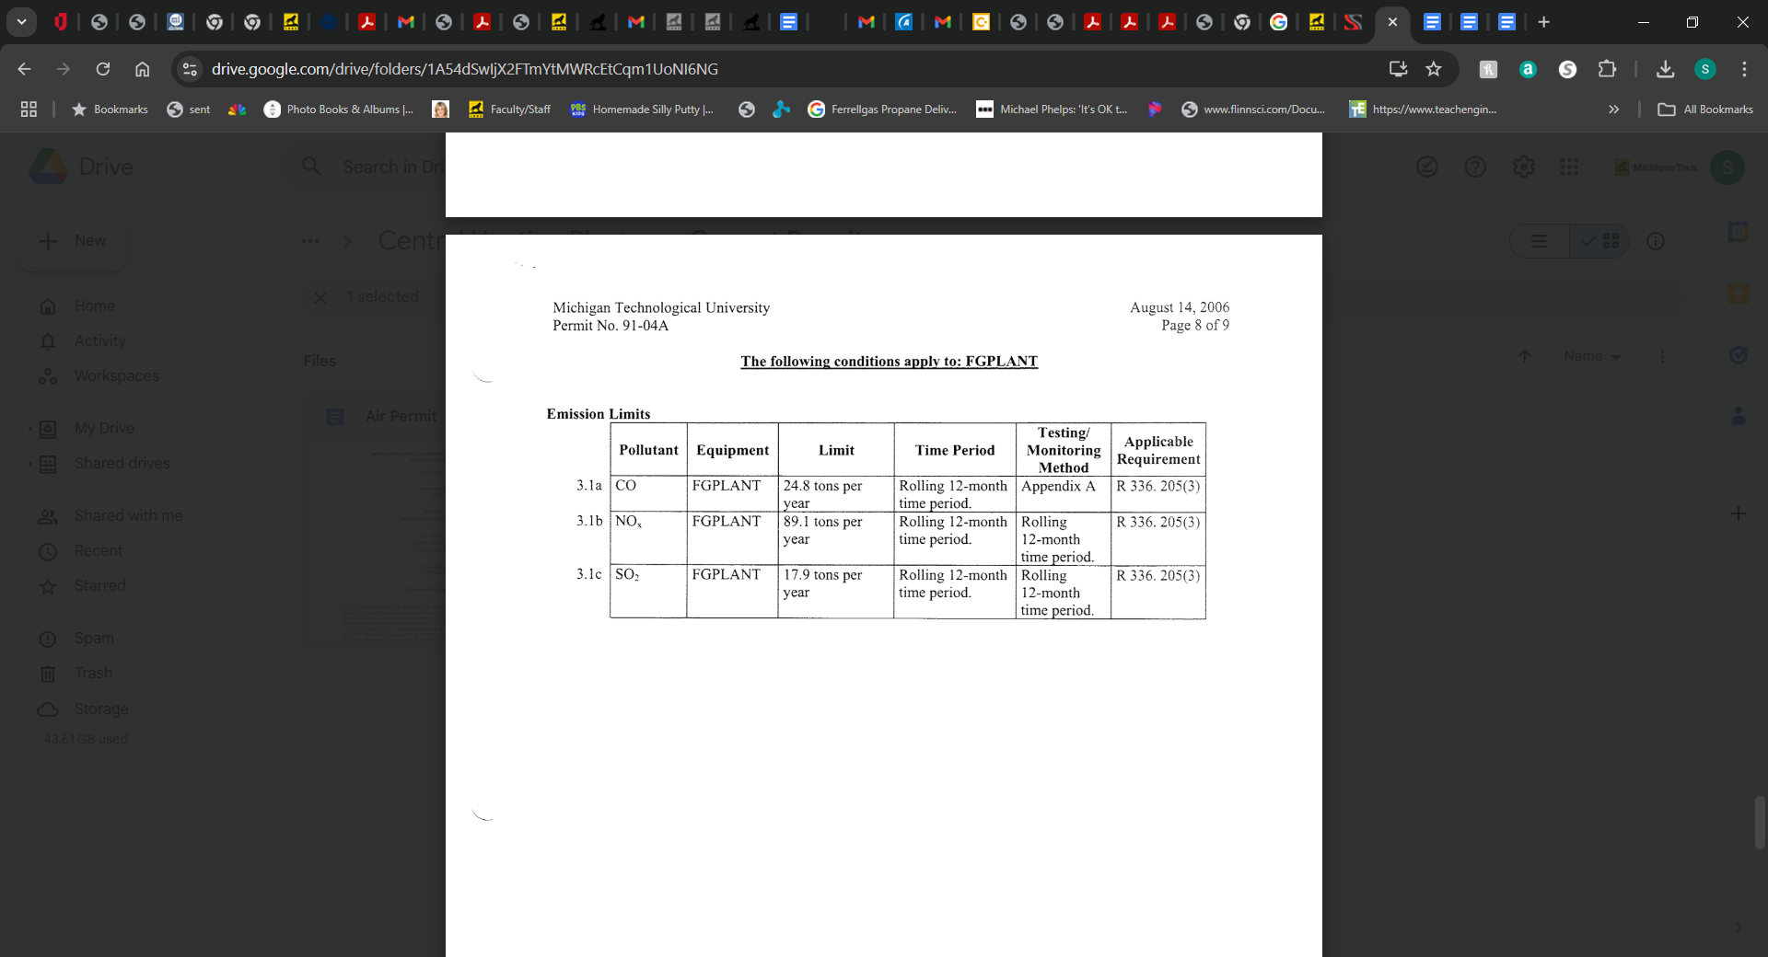

1. **PTI # 91-04A: Appendix A**

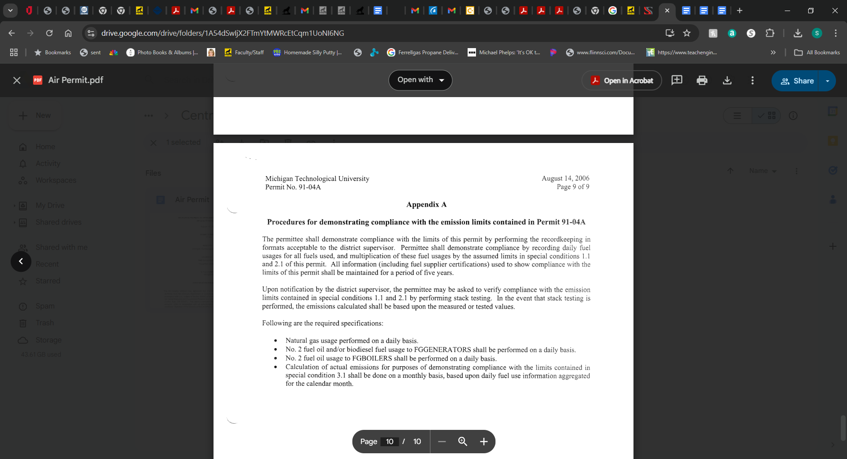

***Appendix B***

**Activity Report: Onsite Inspection EGLE**

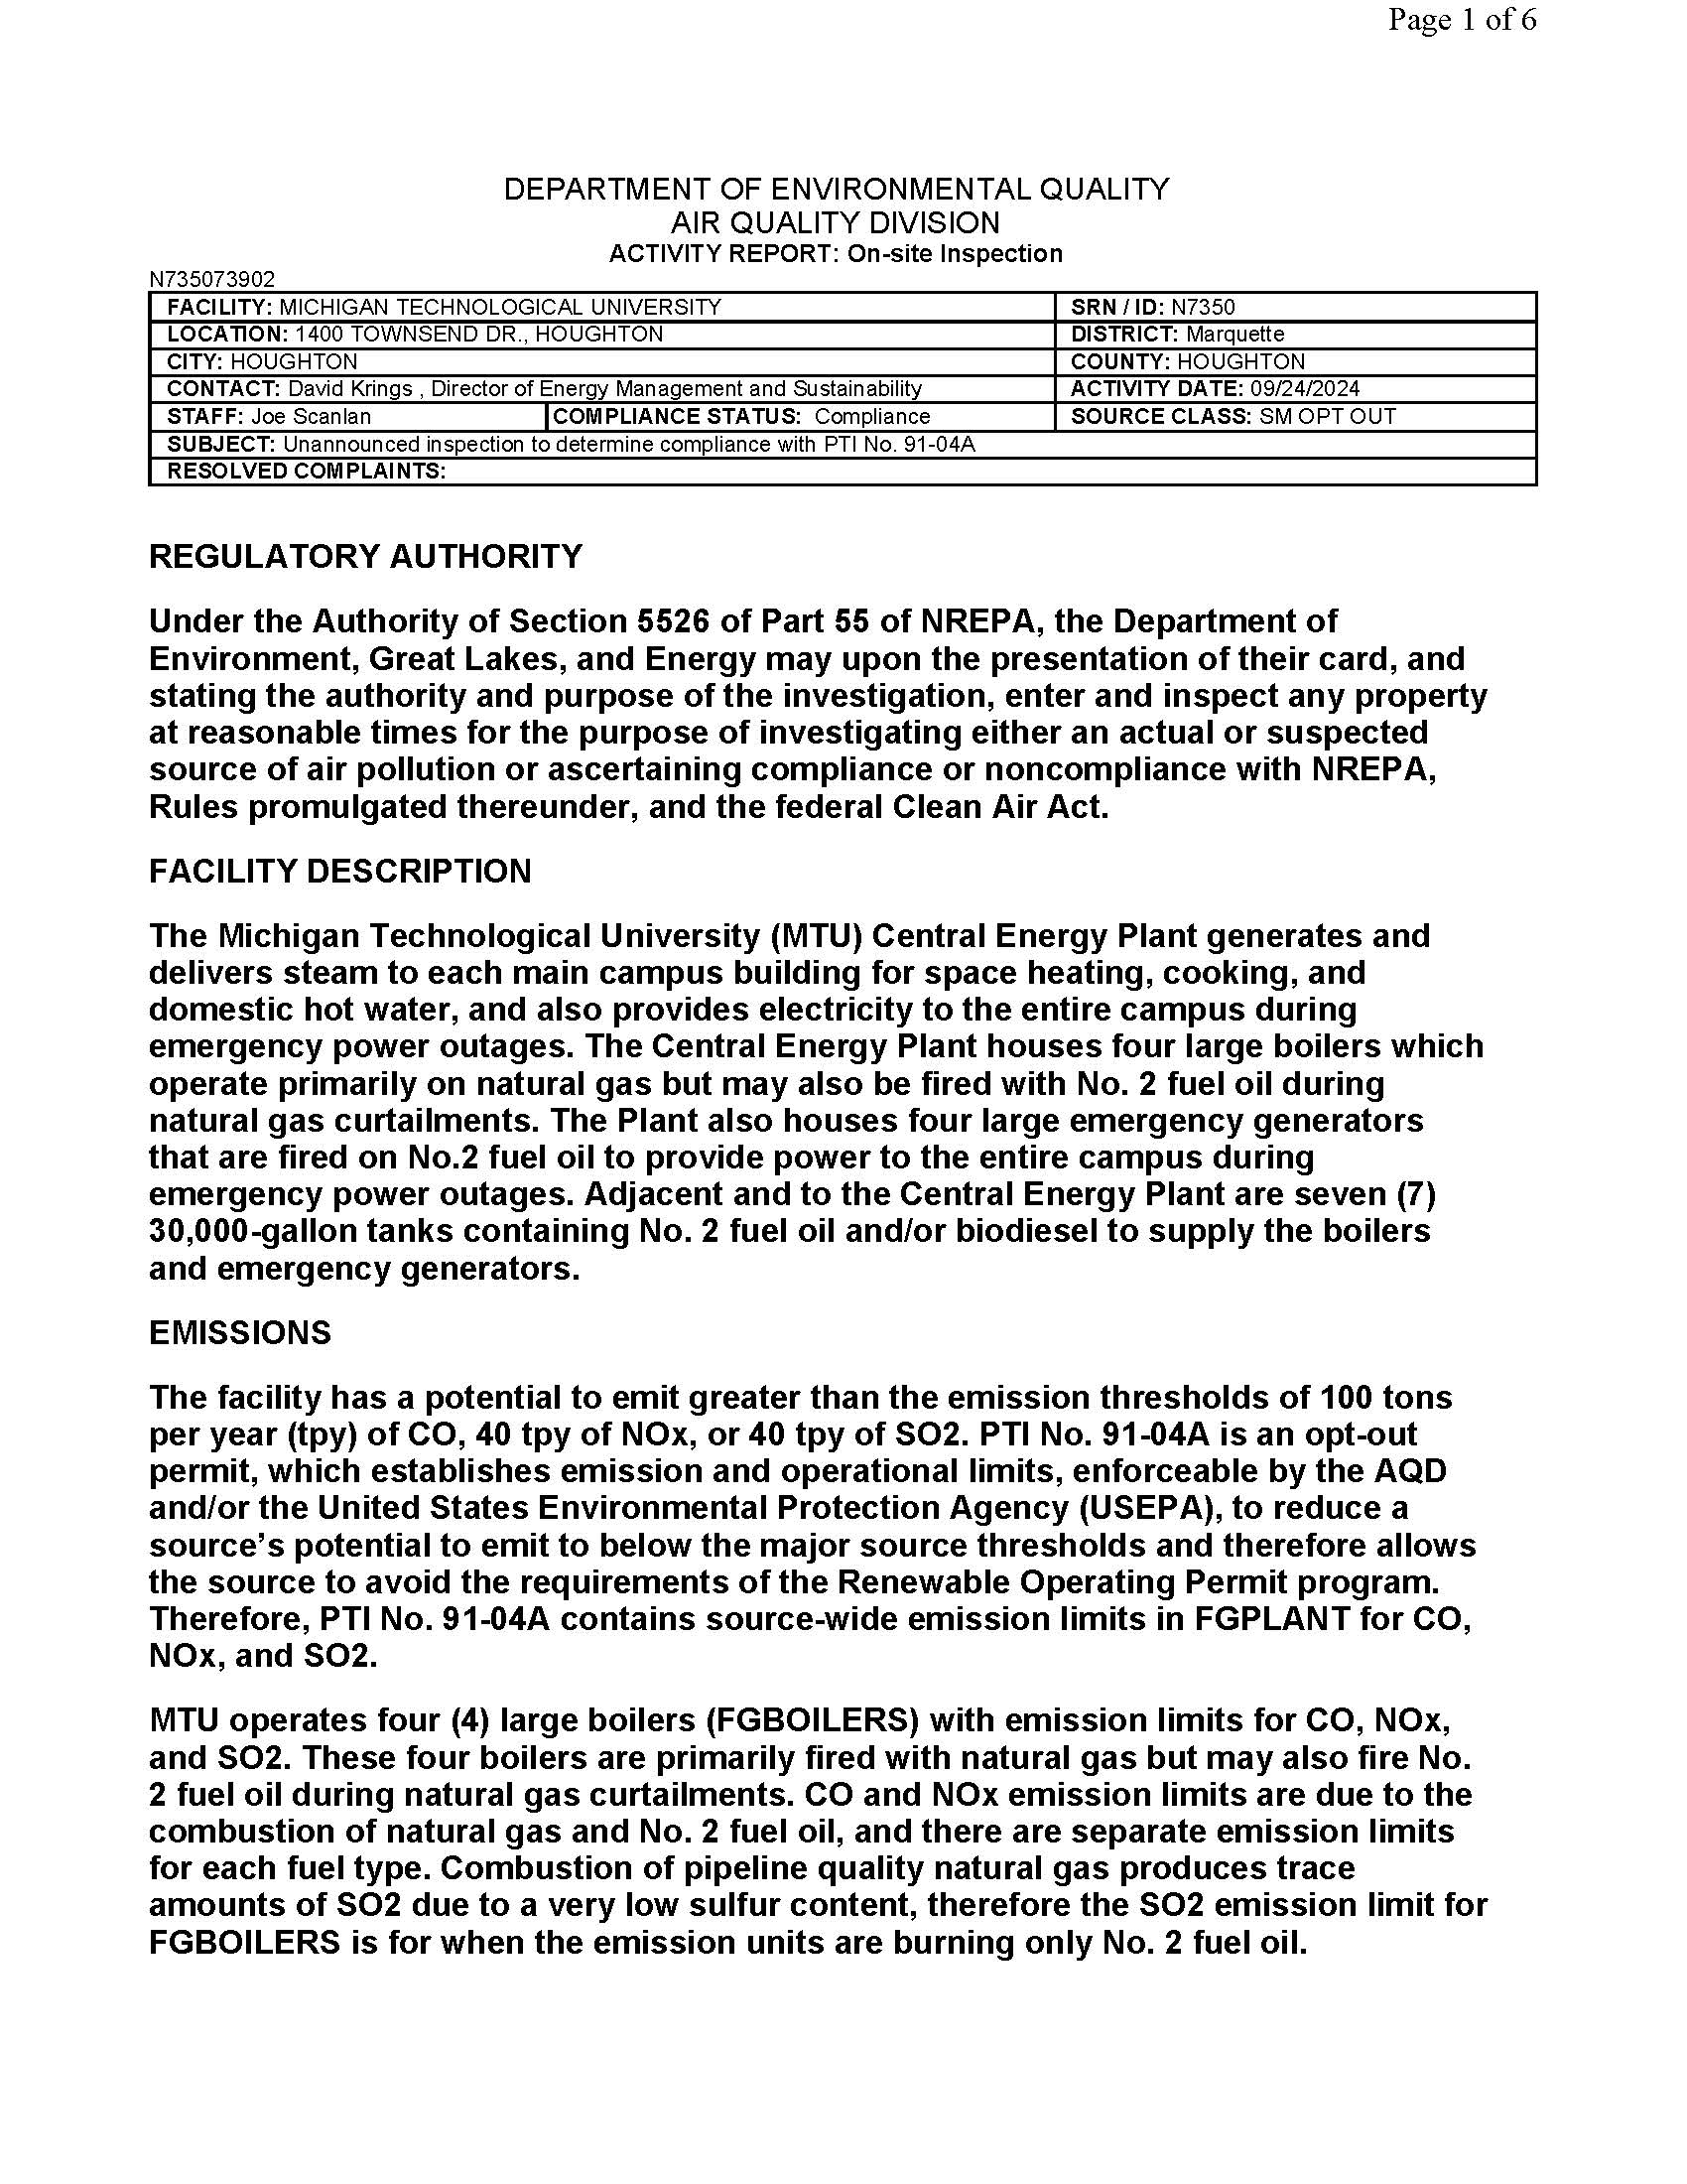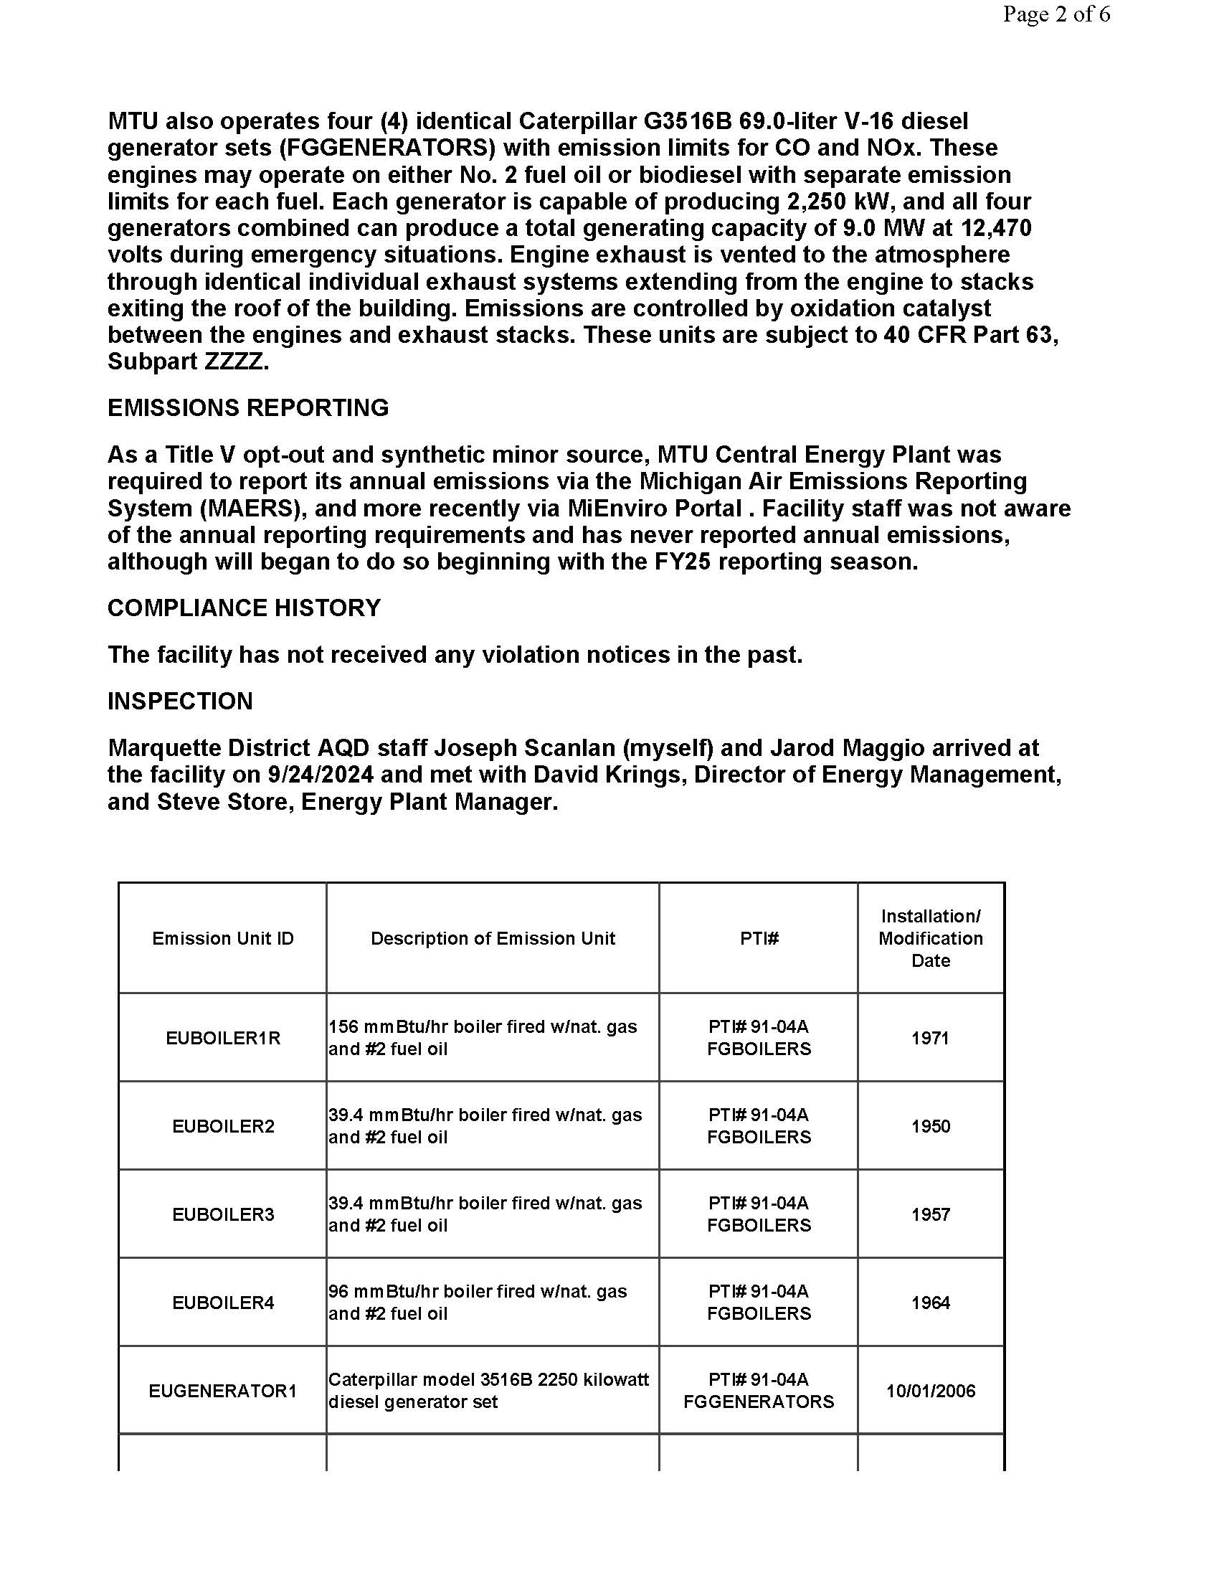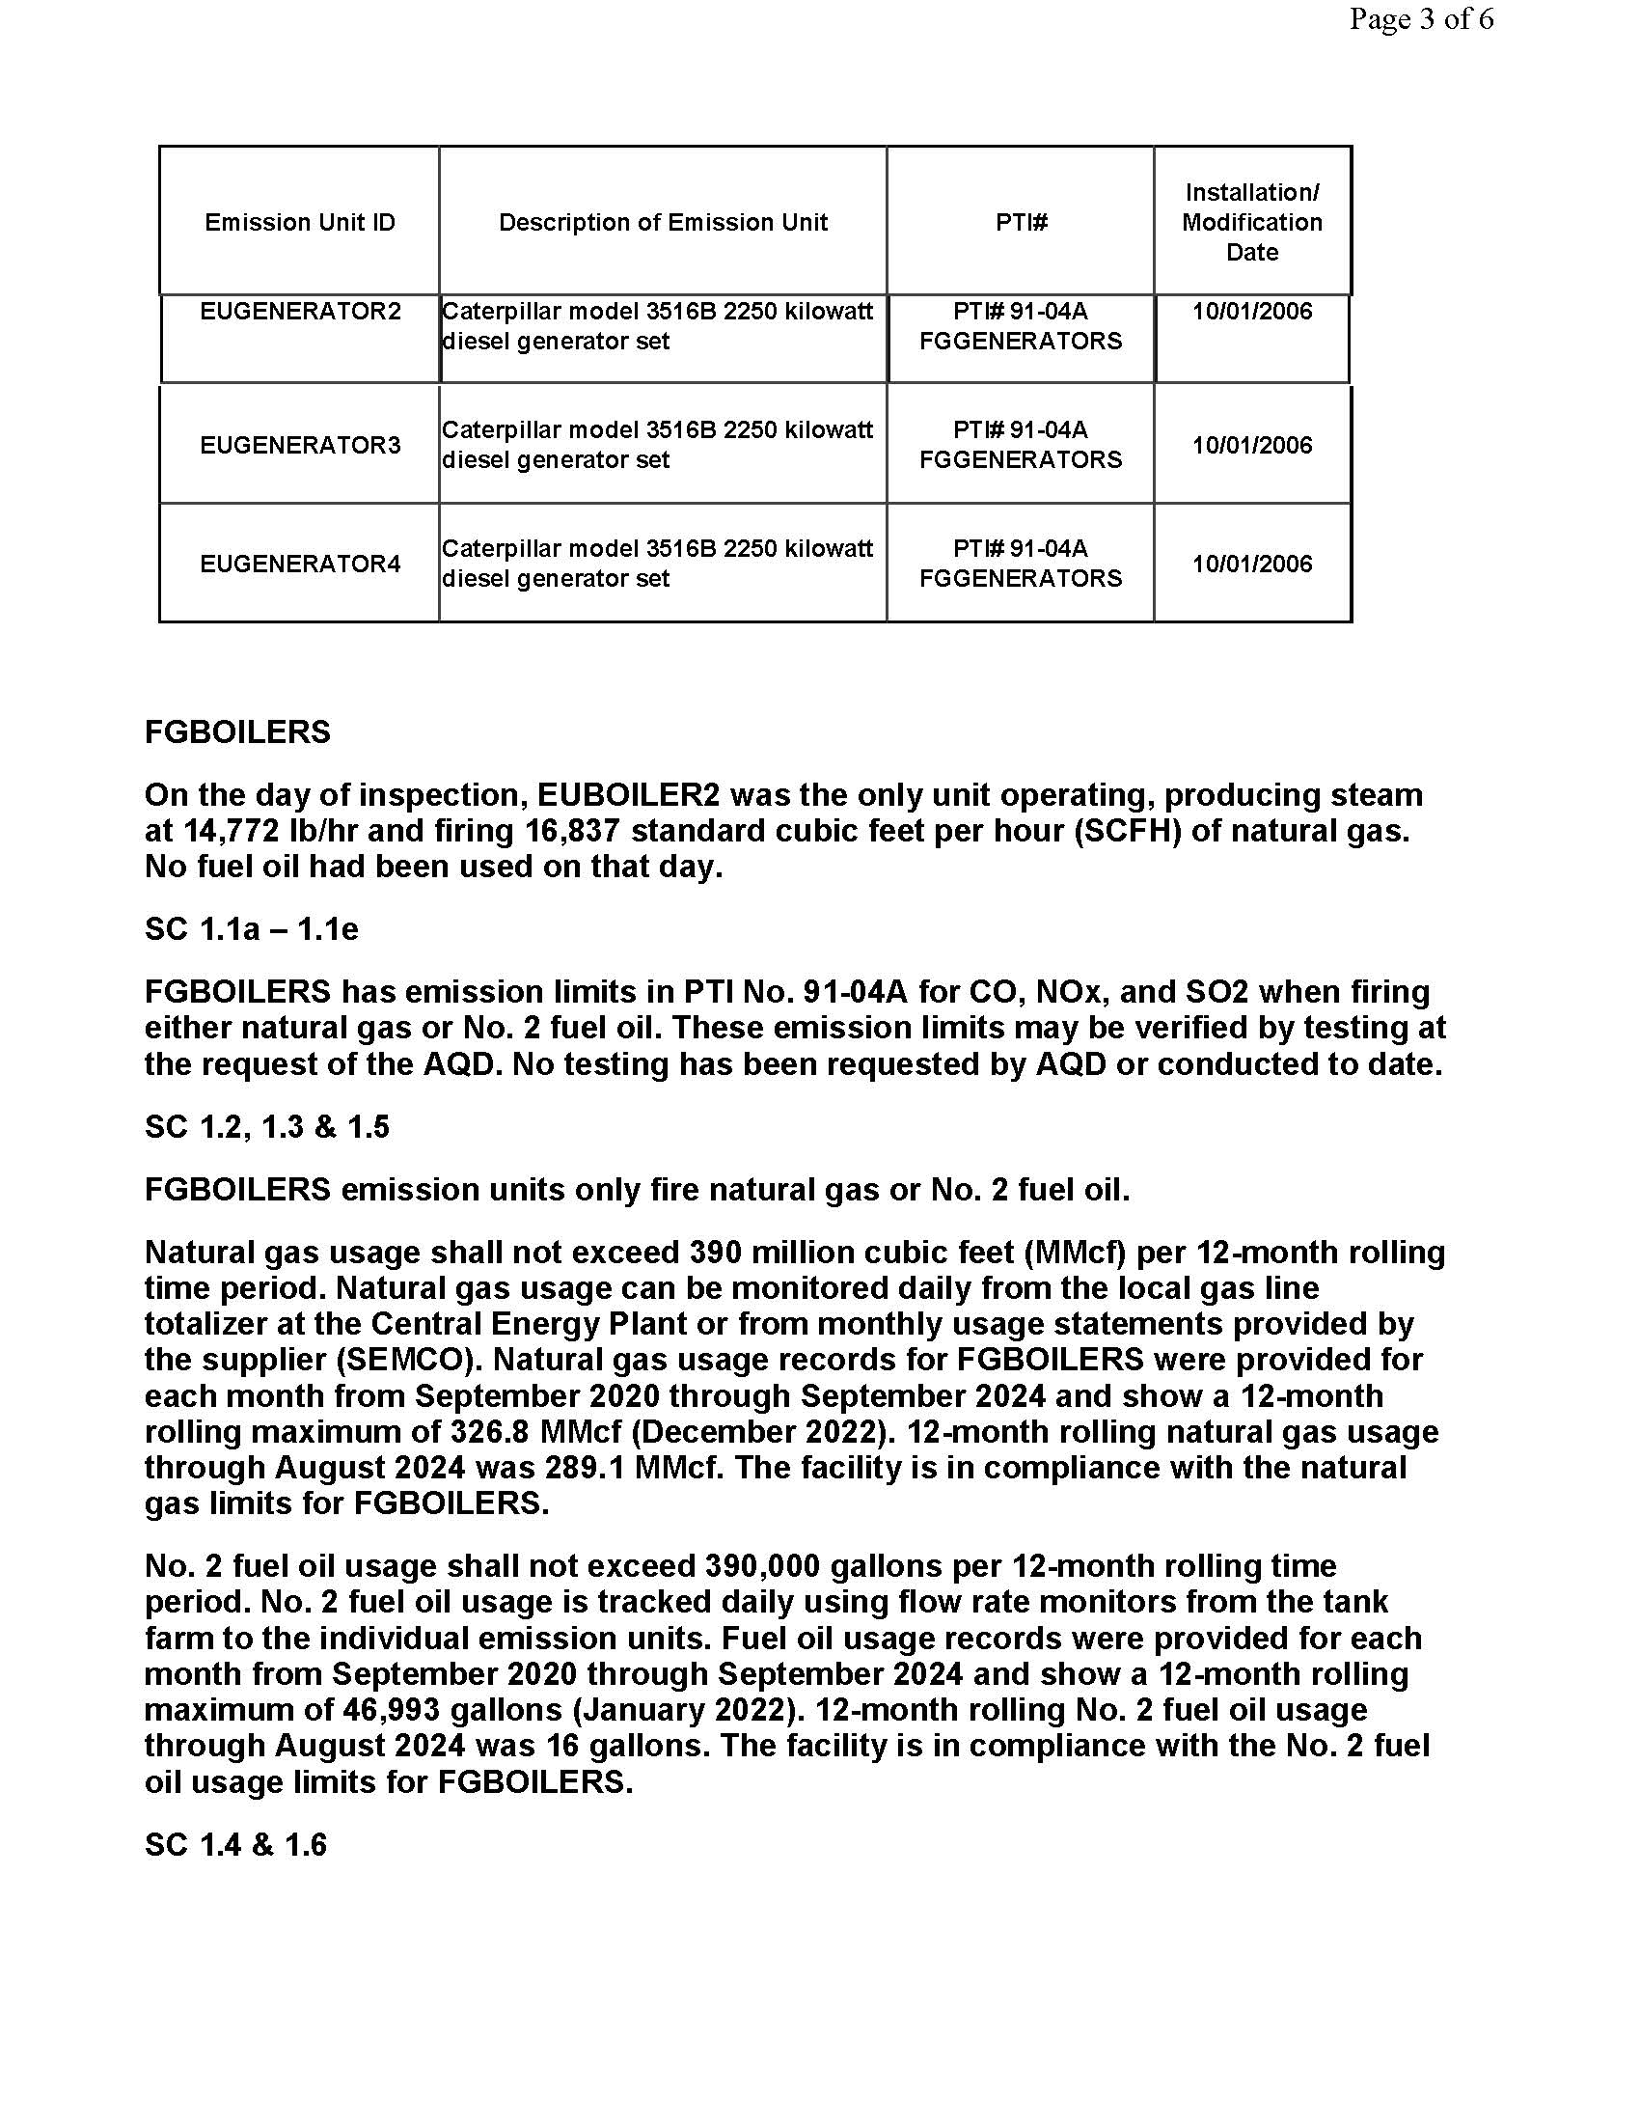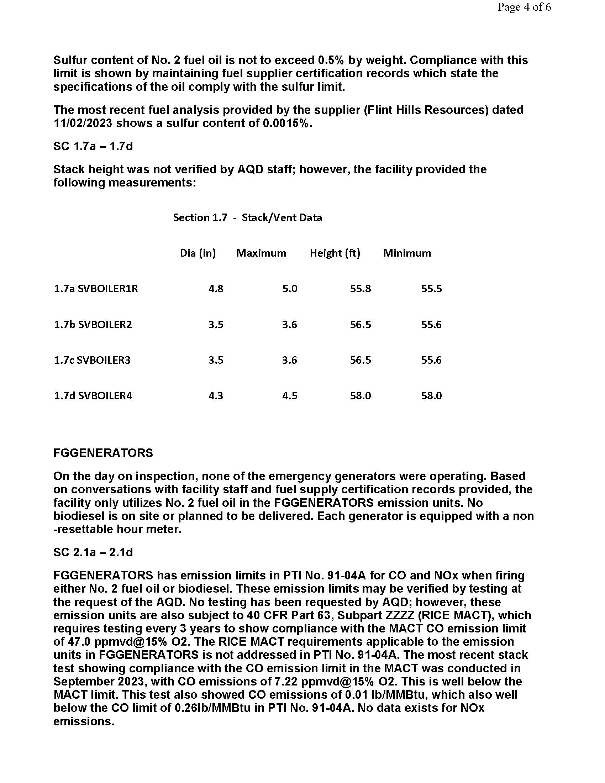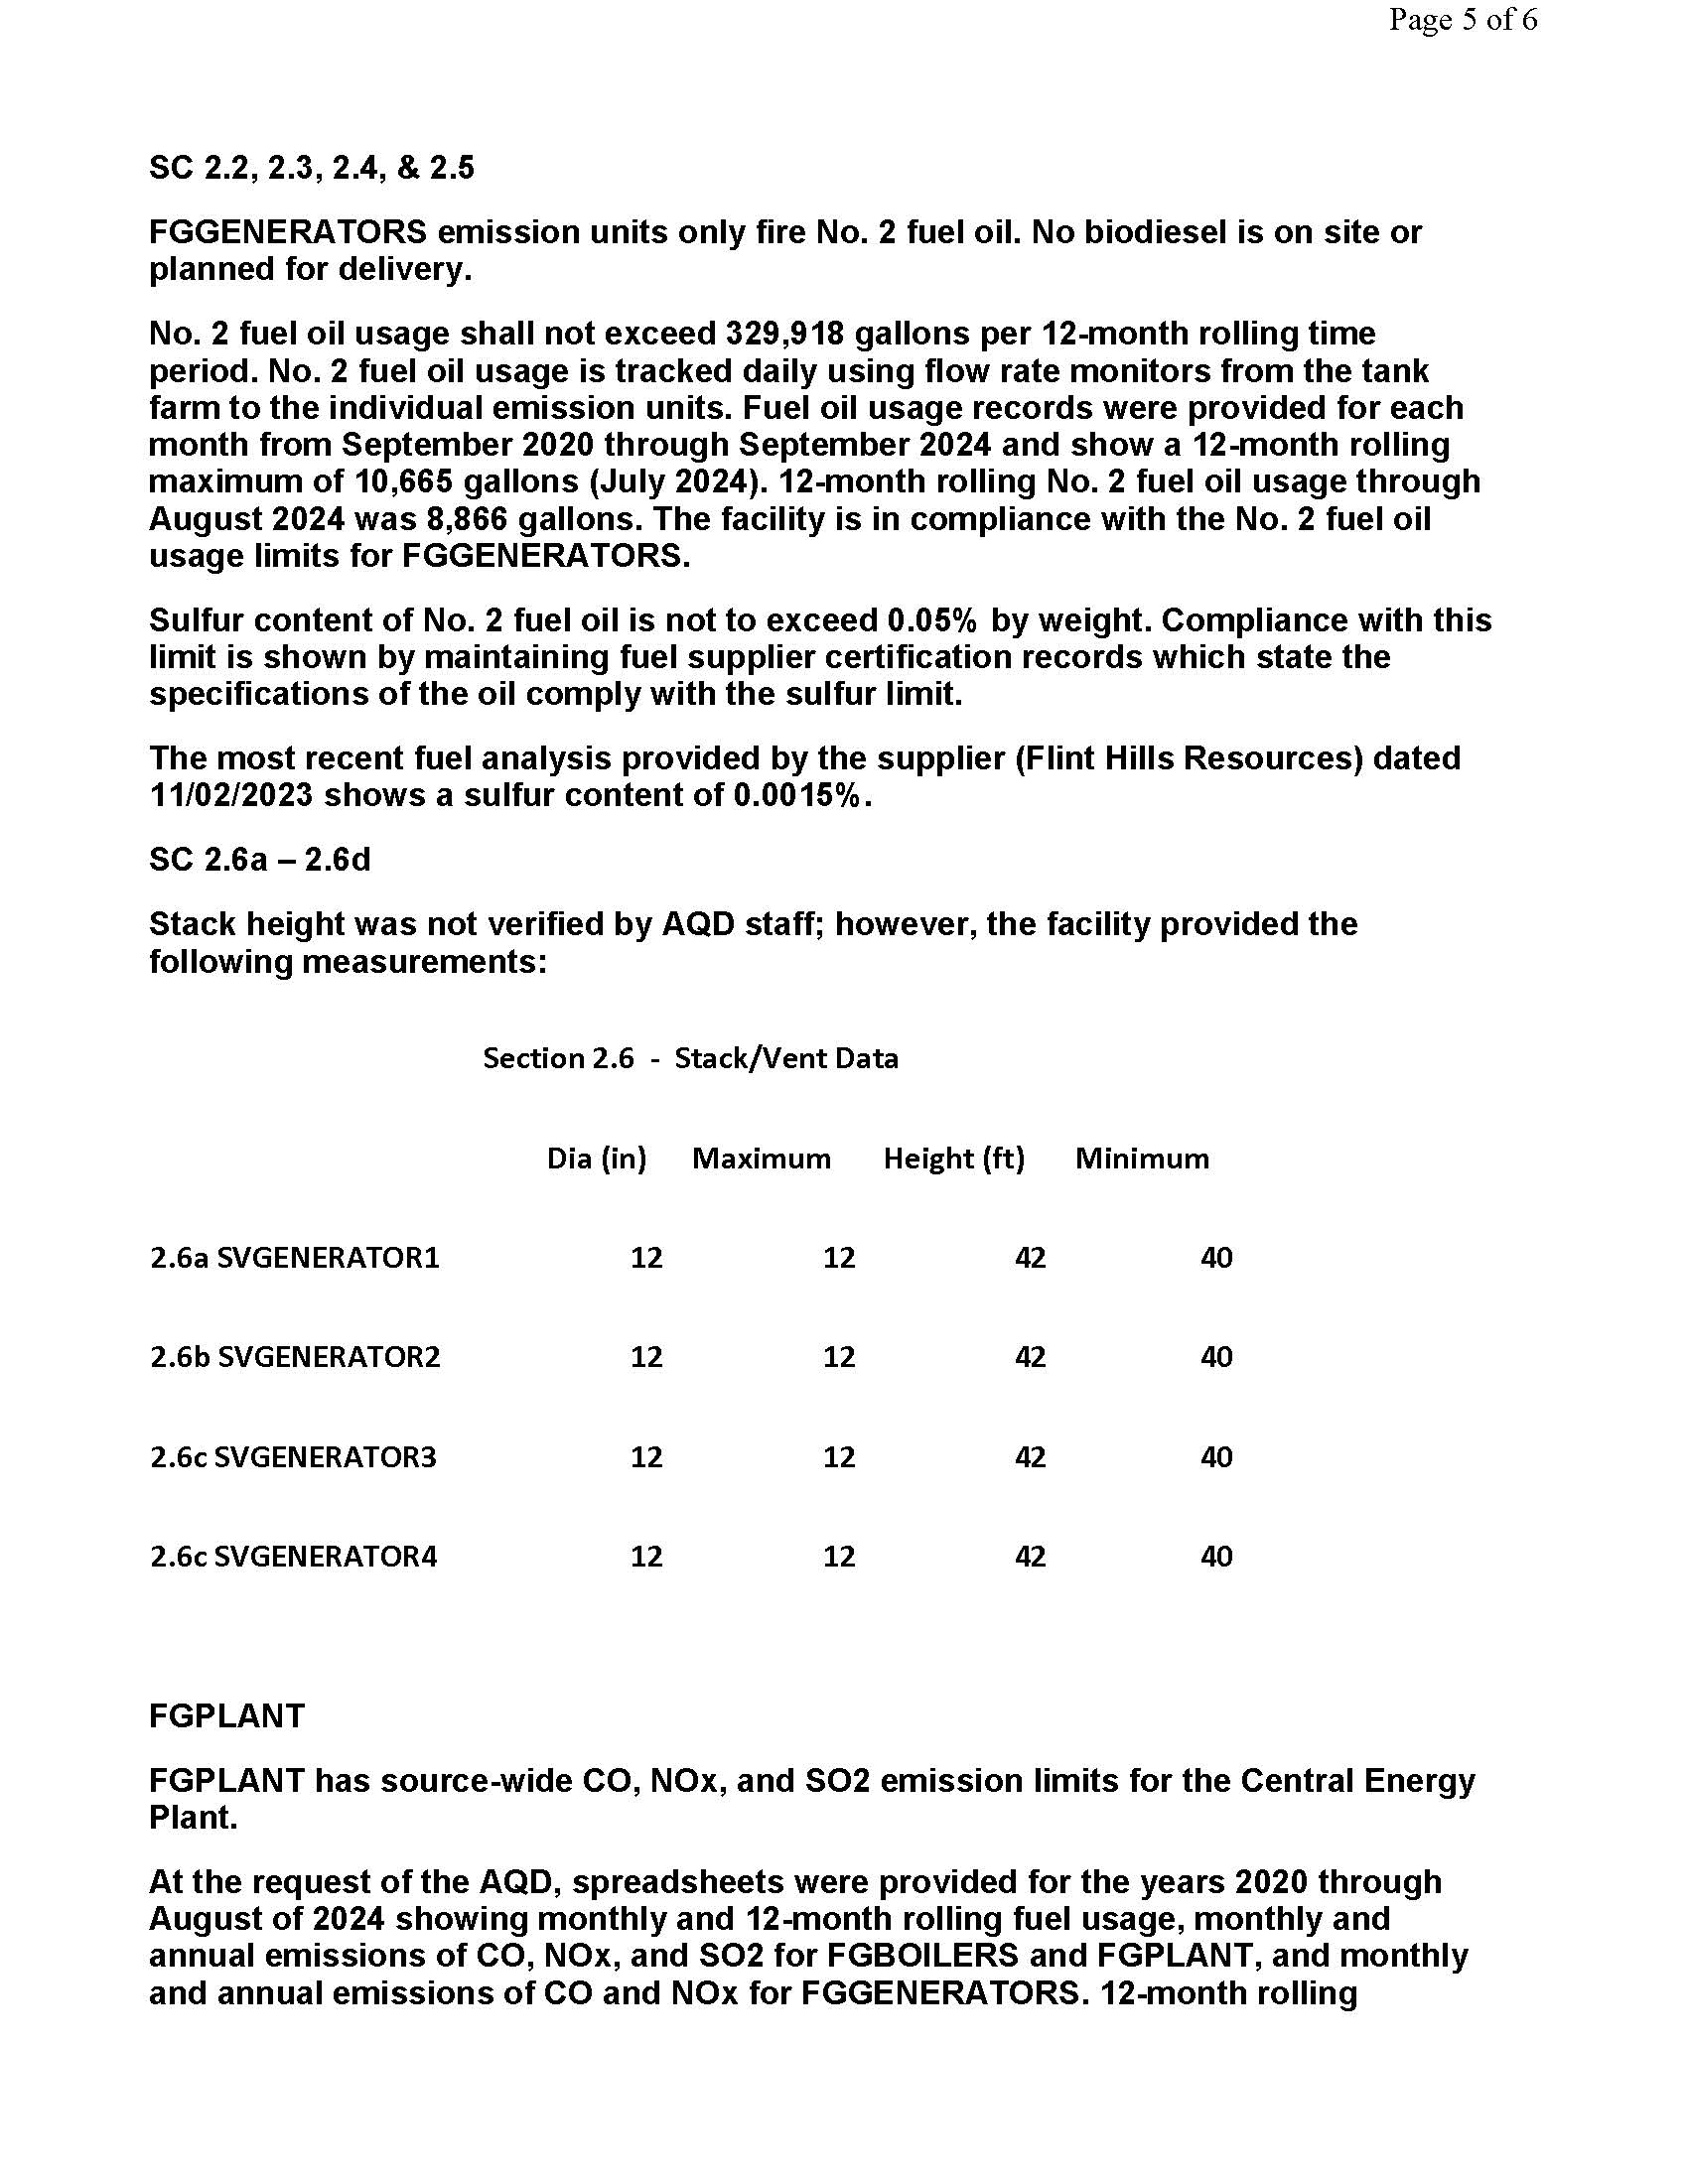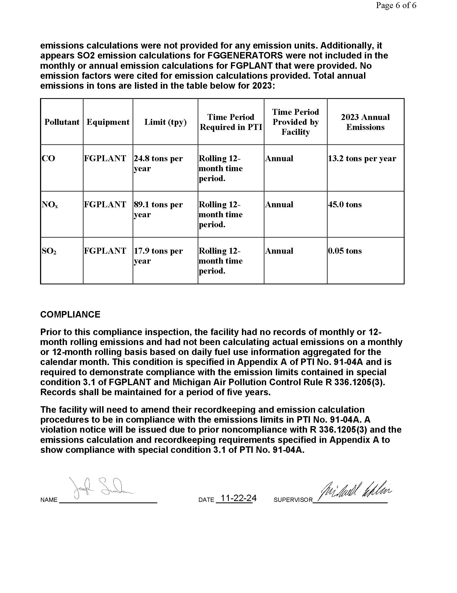***Appendix C***

**Permit to Install # 91-04A**

