[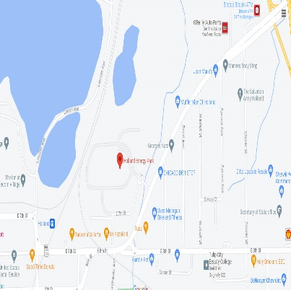](https://www.google.com/maps/place/Holland+Energy+Park/@42.792817,-86.0908753,16.5z/data=!4m15!1m8!3m7!1s0x8819ed5429bceea9:0xee542759f99680e!2sEnergy+Park+Construction+Site,+1+Energy+Park+Way,+Holland,+MI+49423!3b1!8m2!3d42.7924762!4d-86.0907686!16s%2Fg%2F11c1f7rgqq!3m5!1s0x8819ed5429dd9bd5:0x1e49ddd37a1c8b1!8m2!3d42.7924156!4d-86.0921783!16s%2Fg%2F1tkrmdtd?entry=ttu)**NOTICE of AIR PERMIT PUBLIC COMMENT PERIOD**

The Michigan Department of Environment, Great Lakes, and Energy (EGLE), Air Quality Division (AQD) uses public comment periods and hearings to get community input. The public comment period and public hearing (if requested) are to allow the public the opportunity to comment on the proposed conditional approval of the air permits.

**There is a public comment period until August 16, 2023 for:**

**Company:** Holland Board of Public Works – Holland Energy Park, located at 1 Energy Park Way in Holland, Michigan.

**What they want to do:** Renew their Phase II Acid Rain Permit No. MI-AR-59093-20XX

* Electric utility plants that have an output capacity of 25 megawatts or greater are required to obtain and operate in compliance with a Phase II Acid Rain Permit pursuant to Title IV of the Federal Clean Air Act.
* This permit is intended to facilitate active trading of allowances and use of other compliance options to minimize compliance costs; maximize economic efficiency, and permit strong economic growth; and promote pollution prevention and energy efficient strategies and technologies.
* The Acid Rain Permit is intended to achieve environmental benefits through reductions in sulfur dioxide and nitrogen oxide emissions

**Facility Designated Representative:** Joel Davenport, Operations Director.

**Tell us what you think in any of these ways:**

**Get technical reports about this project:**

* Online at the AQD Home Page – [Michigan.gov/Air](http://www.michigan.gov/air) choose the “Public Notice” tab then “[Acid Rain Public Notice Documents](https://www.michigan.gov/egle/0,9429,7-135-3310_70487_6975-387622--,00.html).”
* Call us at 517-416-4631- EGLE, AQD District Office, Jackson, Michigan or in Lansing at 517-284-6811

| MICHIGAN DEPARTMENT OF ENVIRONMENT, GREAT LAKES, AND ENERGY |
| --- |

The decision maker for this permit is Heidi Hollenbach, AQD, Grand Rapids District Supervisor.